**WINTER ISSUE, 2023**

Elizabeth Spahn, President

**Contents:**

*The Sarasota School of Architecture*

*The Ringling College of Art*

*The First Yale Woman on Jeopardy: Donna Wetzler ‘72*

*How Much is a Yale Education Worth: Jobs for the Class of 2022*

*Has Shakespeare Been Ghosted? A Conversation with Murray Biggs and Andy Sandberg*

*Editorial: Yale Alumni Trustee Elections Redux*

*The Yale, Harvard, Princeton Luncheon and The Unhealth of the U.S. Public*

**\*\*\*\*\*\*\*\*\*\*\*\*\*\*\*\*\*\*\*\*\*\*\*\***

**The Sarasota School of Architecture: A Legacy of Innovative Design**

Rick Lannamann & Anne Essner Elizabeth Spann & Marty Hylton

On Tuesday, January 11, the Yale Club of the Suncoast gathered for its first event of the new year at the Sarasota Yacht Club. Rick Lannamann, former President of the Club, introduced Anne Essner, founding Chair of Architecture Sarasota.  Anne is a longtime advocate for preserving "Sarasota School” mid-century modern buildings and for architectural excellence in our community generally.  After a few remarks, Ms. Essner in turn introduced the principal speaker of the event, Marty Hylton, recently appointed Director of the organization. With a master’s degree in historic preservation from Columbia University, Mr. Hylton had spent the past fourteen years at the University of Florida as Director of that institution’s Historical Preservation Program.

During a visually delightful presentation of some fifty minutes, Mr. Hylton took Yale Club members and guests through a brief history of the development of Mid-century Modern architecture in Florida, from its beginnings at various places around the state, to its heyday in Sarasota and the “Sarasota School,” and finally to the preservation of these important historic monuments in and around Sarasota today.

Between roughly 1940 and 1965, the Sarasota area became a center for forward-looking residential and civic architecture, owing in part to the warm climate of Florida. Characterized by open-plan structures with large planes of glass to facilitate natural illumination and ventilation, Sarasota-style architecture aimed to take advantage of the light and fresh air that dominate the environment. Among the leading-light architects who then clustered in Sarasota were Tollyn Twitchell, Paul Rudolph, and Tim Siebert. The term “Sarasota School” is indicative of the fact that the style of architecture they created in the city was important enough to be recognized around the world and merit its own distinctive name.

Among the architects of the Sarasota School with special importance to Yale was Paul Rudolph (1918-1997). Although Rudolph had studied at Harvard with Walter Gropius, creator of the Bauhaus style in Germany in the 1920s, Rudolph served for six years as Chair of the Yale’s Department of Architecture. It was Rudolph who designed the Yale Art and Architecture building, one of the earliest examples of the Brutalist style in America, located, as Yalies likely remember, at the corner of York and Chapel streets in New Haven (see Figure).

Here in Sarasota, remaining exemplars of the Sarasota-style of design can be seen today at many places around the city, perhaps the largest being the addition to Sarasota High School designed by Rudolph in 1960 (see image). Most important for Sarasota School residential architecture is the cluster of three private homes in proximity on Westway Drive on Lido Key: the Zigzag House, the Hiss Studio, and the icon Umbrella House (see figures below). Often, they are available for touring as part of the Architecture Sarasota program, directed by speaker Hylton’s organization. Keep an eye out for the next opportunity for your own personal tour sponsored by this civic-minded group.

Sarasota High School Addition, Paul Rudolph, 1960 Zigzag House, 1332 Westway Drive, Tollyn Twitchell, 1959

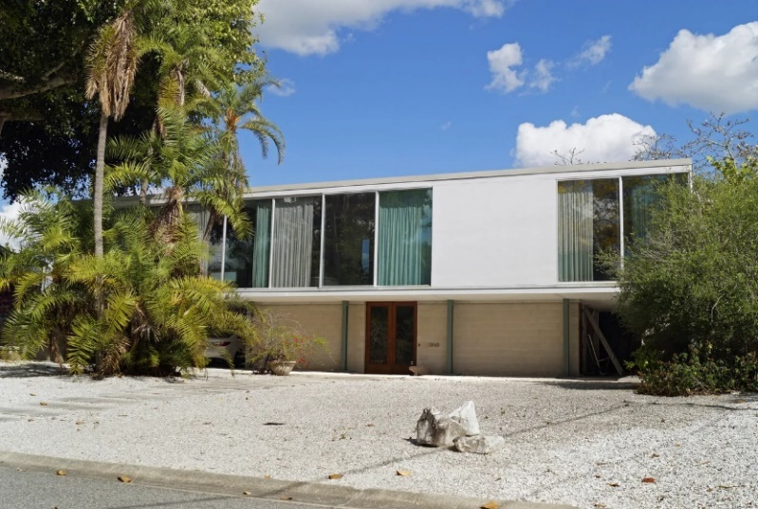

The Hiss Studio, 1310 Westway Drive, Tim Siebert, 1952 Umbrella House, 1300 Westway Drive, Paul Rudolph, 1953

By *BluElines* Staff

**\*\*\*\*\*\*\*\*\*\*\*\*\*\*\*\*\*\***

**The Latest from The Ringling College of Art and Design**

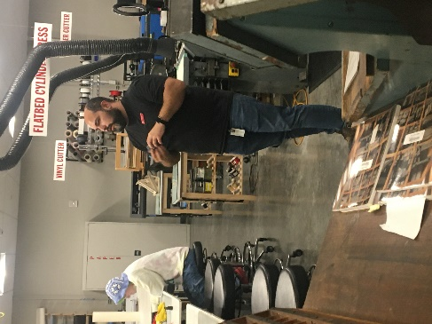

Noah Coleman, Studio Manager and Technician Dr. Jason Good, Vice President

On a balmy evening in late January 2023, almost 50 members of the Yale Club of the Suncoast came together at the Ringling College Sarasota campus to hear about and see some of the most recent changes at the College. Regrettably, President Larry Thompson was unable to attend, but was replaced very capably by Dr. Jason Good, the Vice President for Enrollment Management and Marketing. Before Dr. Good spoke, Yalies toured the “Marketspace” which includes the wood shop, the letterpress and the digital fabrication studio in the Basch Visual Arts Center. Noah Coleman, the Studio Manager and Technician of the Marketspace served as tour guide.

After a sit-down buffet dinner prepared by Sarasota Catering Company, Dr. Good began his presentation with a little bit of history. When the College first opened its doors in 1931, it had an entering class of 75 students and 13 faculty. Founded right on the heels of the Great Depression, the College was established as the School of Fine and Applied Art at the John Ringling Art Museum and Junior College, with John Ringling as the primary benefactor. The Ringling School continued to grow throughout the years and received accreditation by the Southern Association of Colleges and Schools in 1979, and by the National Association of Schools of Art and Design in 1984. After Dr. Larry Thompson assumed the presidency in 1999, the institution added “and Design” to its name.

Reflecting the growth in the latest technical innovations of art and design, the Ringling campus is now spread over more than 60 acres. It hosts approximately 1,700 students with 20% coming from foreign countries. All students receive some form of financial assistance. The major facilities include the Goldstein Library, the Basch Visual Arts Center (including Marketspace), Ringling College Studio Labs (including the two 8,400 sq. ft. soundstages), residence halls, and, as of 2023 Cunniffe Commons, a state-of-the art dining room. Ringling offers 11 undergraduate BFA degrees in fields such as Virtual Reality Development, Game Art and Entertainment Design, as well as two BA degrees, including Visual Studies, specialized concentration tracks in addition to ten minors. Currently, Ringling is ranked #1 in the U.S. for Computer Animation, #2 for Motion Design and #3 in the world in both Illustration and for Game Development. Over the years, graduates have been employed by nearly 100 companies, including Disney, Apple, Netflix and Microsoft. Dr. Good emphasized that in his opinion, the most important mission of the faculty and administration is to develop students’ creativity so they can survive in the rapidly changing employment environment of today. It is estimated that those who are current students will have eight different careers throughout their professional lives, and four of those have not been created yet! The Ringling College of Art and Design intends to be a leader in the new Creative Age. At the end of Dr. Good’s fine presentation, he responded to many questions posed by the Yale audience.

Nick Gladding, Co-Editor

************

**First Yale Woman Jeopardy Contestant:**

**A New Member of the Club**

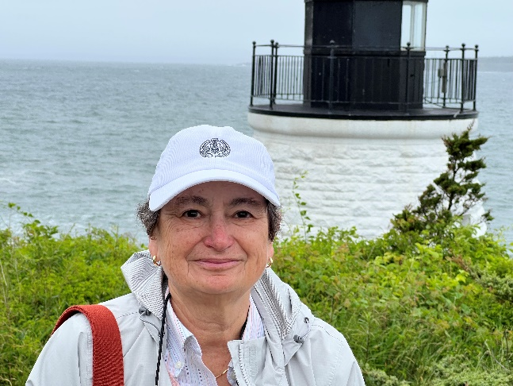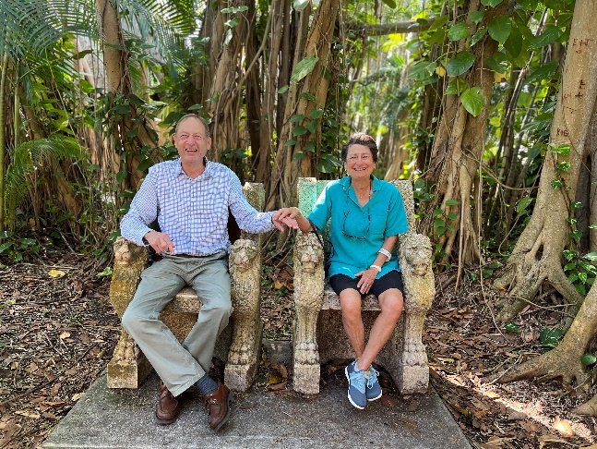

Donna Wetzler ’72 Bill Webb ’71 & Donna Wetzler

(newly arrived on Lido Key)

If you were attending Club meetings this fall (2022), you may have had the pleasure of meeting petite, energetic Donna Wetzler. Donna (Yale ‘72) and her husband Bill Webb (Yale ‘71), recently moved to Sarasota from Chicago, where they both had distinguished legal careers. During a recent discussion with Donna, we somehow got on the subject of Jeopardy, where she quietly let drop that she had once been a contestant on the show. This unexpected bit of news piqued my curiosity, so I asked the expected “how, when, and where” questions, as well as one rude one: “did you win anything?” To all of the above, Donna later replied in an email along the following lines:

“Throughout high school, I watched College Bowl and Jeopardy and was on the Chicago local high school team trivia show (It’s Academic). When I came to Yale in 1969 (the first-year women were admitted) I was a sophomore transfer from Smith). I played home Jeopardy a lot with Yale male buddies of mine and decided that, since Yale women were rather a novelty, that fact might be a good gimmick to get me selected for real life Jeopardy. I applied and was invited to come to NYC to take a written test, which I must have passed because I was selected. I was told to bring three different outfits because three shows were taped on the same day.

“My Yale friend Baker and I, along with my three outfits, took the train down to the Big City. All I really remember before the game was a noticeable security presence (to prevent cheating) and that Don Pardo (then the announcer) warmed up the audience a bit…the host was Art Fleming (this was *way* before Alex Trebek and also much before Jeopardy became wildly popular). I won the first “day,” including the final Jeopardy question. I am sure that I must have been introduced as a Yale student. The second day I was overly cautious. I was ahead by the final Jeopardy question but did not wager enough to win (dumb--I had this idea that I was risking real money and I got too conservative.) The only question I remember from the two shows was: “What university has the largest gym in the U.S.” I also remember probably not giving a very politically correct answer when Art Fleming asked what I was planning to do with my first day winnings…my response: “Have a big party” (which I did ..which was kind of unusual…I was at Yale during a very serious political time and there weren’t a lot of parties or really very much fun at all; in fact, the second semester was, I think, shortened two of the three years I was there (one due to the dining hall strike and one due to the Black Panther/Kent State turbulence…but I digress). I won $1800 [about $14,000 in money of today] as well as a set of the Encyclopedia Americana and a home Jeopardy game. And I did have a big party (in Branford, my college). Chapel Liquors was my purveyor of choice.”

Great story, Donna, and great memory! Maybe the story will carry you back, dear reader, along memory lane to New Haven during those transformative times. If so, share your experiences with us and Donna at a future Club meeting.

Craig Wright, Co-Editor

**\*\*\*\*\*\*\*\*\*\*\*\***

**How Much is a Yale Education Worth?**

Silly question, admittedly. But for the sake of argument: how might one value a college education? By the factual information you learn, the associations you make, the degree to which your curiosity is stimulated or your capacity for critical thinking increases, how much good you are prepared to do as you go out into the world, or how much money you make? Surely not the latter. But then again . . . . How much does a newly-minted Yalie take home that first year? On February 15, 2023, Yale’s Office of Career Strategy released the following statistics regarding employment for the Class of 2022 measured six months after graduation, and the following is taken directly from that report. Those readers following a higher moral authority, please avert your eyes.

* “The survey resulted in an 85.7% knowledge [response] rate and of those with known post-graduate outcomes, 95.8% reported confirmed plans.
* Three-quarters (75.7%) of graduates are employed, with the next largest group (17.9%) attending graduate school.
* 74.7% of those employed intend to pursue graduate school within the next five years.
* 89.9% of graduates stated that their plans were related to their area of study at Yale.
* Among those employed:
  + 68.8% are working with a for-profit company, while 31.2% are working with a non-profit organization, NGO, government, or other public agency.
  + Average starting annual base salary in the U.S. is $81,440, an increase from $76,359 in 2021
  + Among graduates reporting their salary, more than 40% received a signing bonus and the average bonus was $19,739.
  + 61.2% secured their full-time position in the spring of senior year or later.
* More than eighty percent of respondents (80.2%) reported using OCS career resources during their time at Yale.

Maybe Jerry McGuire was right.

By BluElines Staff

**\*\*\*\*\*\*\*\*\*\*\*\***

**A Conversation with Murray Biggs and Andy Sandberg:**

**The Theater, Shakespeare and the Arts**

Yale’s Dynamic Duo, Andy Sandberg and Murray Biggs

Has Shakespeare, like the ghost at the beginning of *Hamlet*, been ghosted by Yale? Stick around and hear what Murray Biggs and Andy Sandberg have to say.

On February 2, 2023, at the Sarasota Yacht Club, members and guests of the Yale Club of the Suncoast were instructed and entertained not by one speaker but two. Former Club president Nick Baskey introduced the power pairing: Murray Biggs and Andy Sandberg. Murray Biggs is retired Associate Professor (Adjunct) of Theater Studies and Andy Sandberg (‘06) Artistic Director and CEO of the Hermitage Foundation of Manasota-Sarasota. Murray taught at Yale for thirty-five years and continues to do so in the Yale Alumni College program. Andy was formerly the business manager of the Alley Cats and the Whiffenpoofs as well as the youngest winner of a Tony Award for Production. Not a formal lecture, their conversation was something akin to a high-end improv session. Looking back on their careers in the theater and at Yale, here follows only three of the observations they made about the changing world of the theater and of Yale.

The curriculum at Yale has taken an unexpected turn. Twenty years ago, if an instructor offered a lecture course on Shakespeare in the English Department, about two hundred would enroll. Today, one would be lucky to get sixty. Currently, there are no lecture courses on Shakespeare. In earlier days, a course on Shakespeare was required, either *de jure* or *de facto*, of every English major. This is no longer the case. The focus on campus, rightly or wrongly, has shifted to political activist topics. Similarly, support for theater-specific, humanities-specific, or English-department-specific donations to Yale are sometimes not as encouraged by the Development Office as are gifts to the “general fund” where the money can be shunted to programs elsewhere. The English Department and the History Department formerly were bastions of Yale College. The importance of the latter has, perhaps surprisingly, stayed strong, but less so the former. When a senior faculty in English retires, often he or she is not replaced.

The economics of the theater on Broadway have also changed, in ways similar to what is happening in London. Production costs have become unsustainably high. The revival of *Hair,* for example had an initial production cost of $4-5 million whereas the more recent revival of *Moulin Rouge* was roughly $22 million. The inflation is seemingly due to producers’ reluctance to work line by line through a prospective show’s estimated cost and cut the excess. Thus, despite a resurgence of Broadway, most shows are not recouping their initial capitalization and “staying time” on Broadway is becoming shorter. Also becoming shorter are the run times of a show. Producers increasing want shorter shows with smaller casts—again, owing to costs.

Finally, advice to a young person about to enter college and possibly wishing to take up the theater as a career. Be the fox, not the hedgehog. Get out there and embrace as diversified a curriculum as you can. Similarly, participate in a wide range of extracurricular activities.

Thus an implicit take-away from the Biggs-Sandberg conversation: Shakespeare is good and so is a true “liberal” (freeing) education.

Craig Wright, Co-Editor

**\*\*\*\*\*\*\*\*\*\*\*\***



**Yale Alumni Fellow Elections Redux: *The Yale Daily News Weights In***

Editorial

In the November 2021 issue of *BluElines,* we reported on the bruhaha surrounding a change in policy regarding election to the Yale Board of Trustees (Corporation). At issue was the decision of the Corporation to eliminate a process—in effect for almost a century--whereby an alumnus/a could become a candidate for the Board if he or she were supported by a petition containing the signatures of 3% of alumni.

In January of 2023, *The Daily News* held a referendum among students on the issue, the results of which were published in its edition of February 8, 2023. Titled “Students Overwhelmingly Support Democratization of Trustee Elections,” the article reported that nearly 90% of the approximately 2,000 students who voted were in favor of the following proposition. “Should the board of trustees for Yale Corporation consist of democratically elected trustees?”

On February 9, 2023, the *Wall Street Journal--*ever eager to point out possible trouble in Eli Land--published an editorial titled “Make Yale Democratic Again.” It recapped the results of the story in the *Daily News,* but added useful contextual information, which reads as follows.

“[*The Daily News* referendum] is the latest backlash against Yale’s May 2021 decision to eliminate a process that had allowed alumni to become candidates for the board if they submitted 4,394 signatures (3% of alumni) on a petition. Now only candidates nominated by the official Alumni Fellow Nominating Committee qualify. A Connecticut lawsuit filed by two alumni accuses Yale of voter suppression and will proceed to trial some time this spring.

The Yale corporation consists of the president, six trustees elected by alumni, 10 appointed members and two ex-officio members (Connecticut’s governor and lieutenant governor). Even when Yale allowed alumni candidates by petition, the last one to be elected to the board was William Horowitz in 1965—the first Jewish trustee.

Yale is far from alone. Harvard in 2020 limited the number of petition Overseers to one-fifth of the board. In 2007 Dartmouth rigged its process by doubling the number of appointed members to stack the board and reduce the influence of any free-thinkers after three had won seats. ‘It is demoralizing that my alma mater is slamming the door on challenges to a status quo that grows more stale every day,’ says Michael Poliakoff, Yale ’75 and president of the American Council of Trustees and Alumni.”

Demoralizing or not, the Yale Board of Trustees has not reversed its May 2021 decision to remove the “outsider route” to the Board. Stand by to see if the aforementioned lawsuit, brought by alumni Victor Ashe ’67 and Donald Glascoff ’67, will bring that to an end.

Craig Wright, Co-Editor

*************

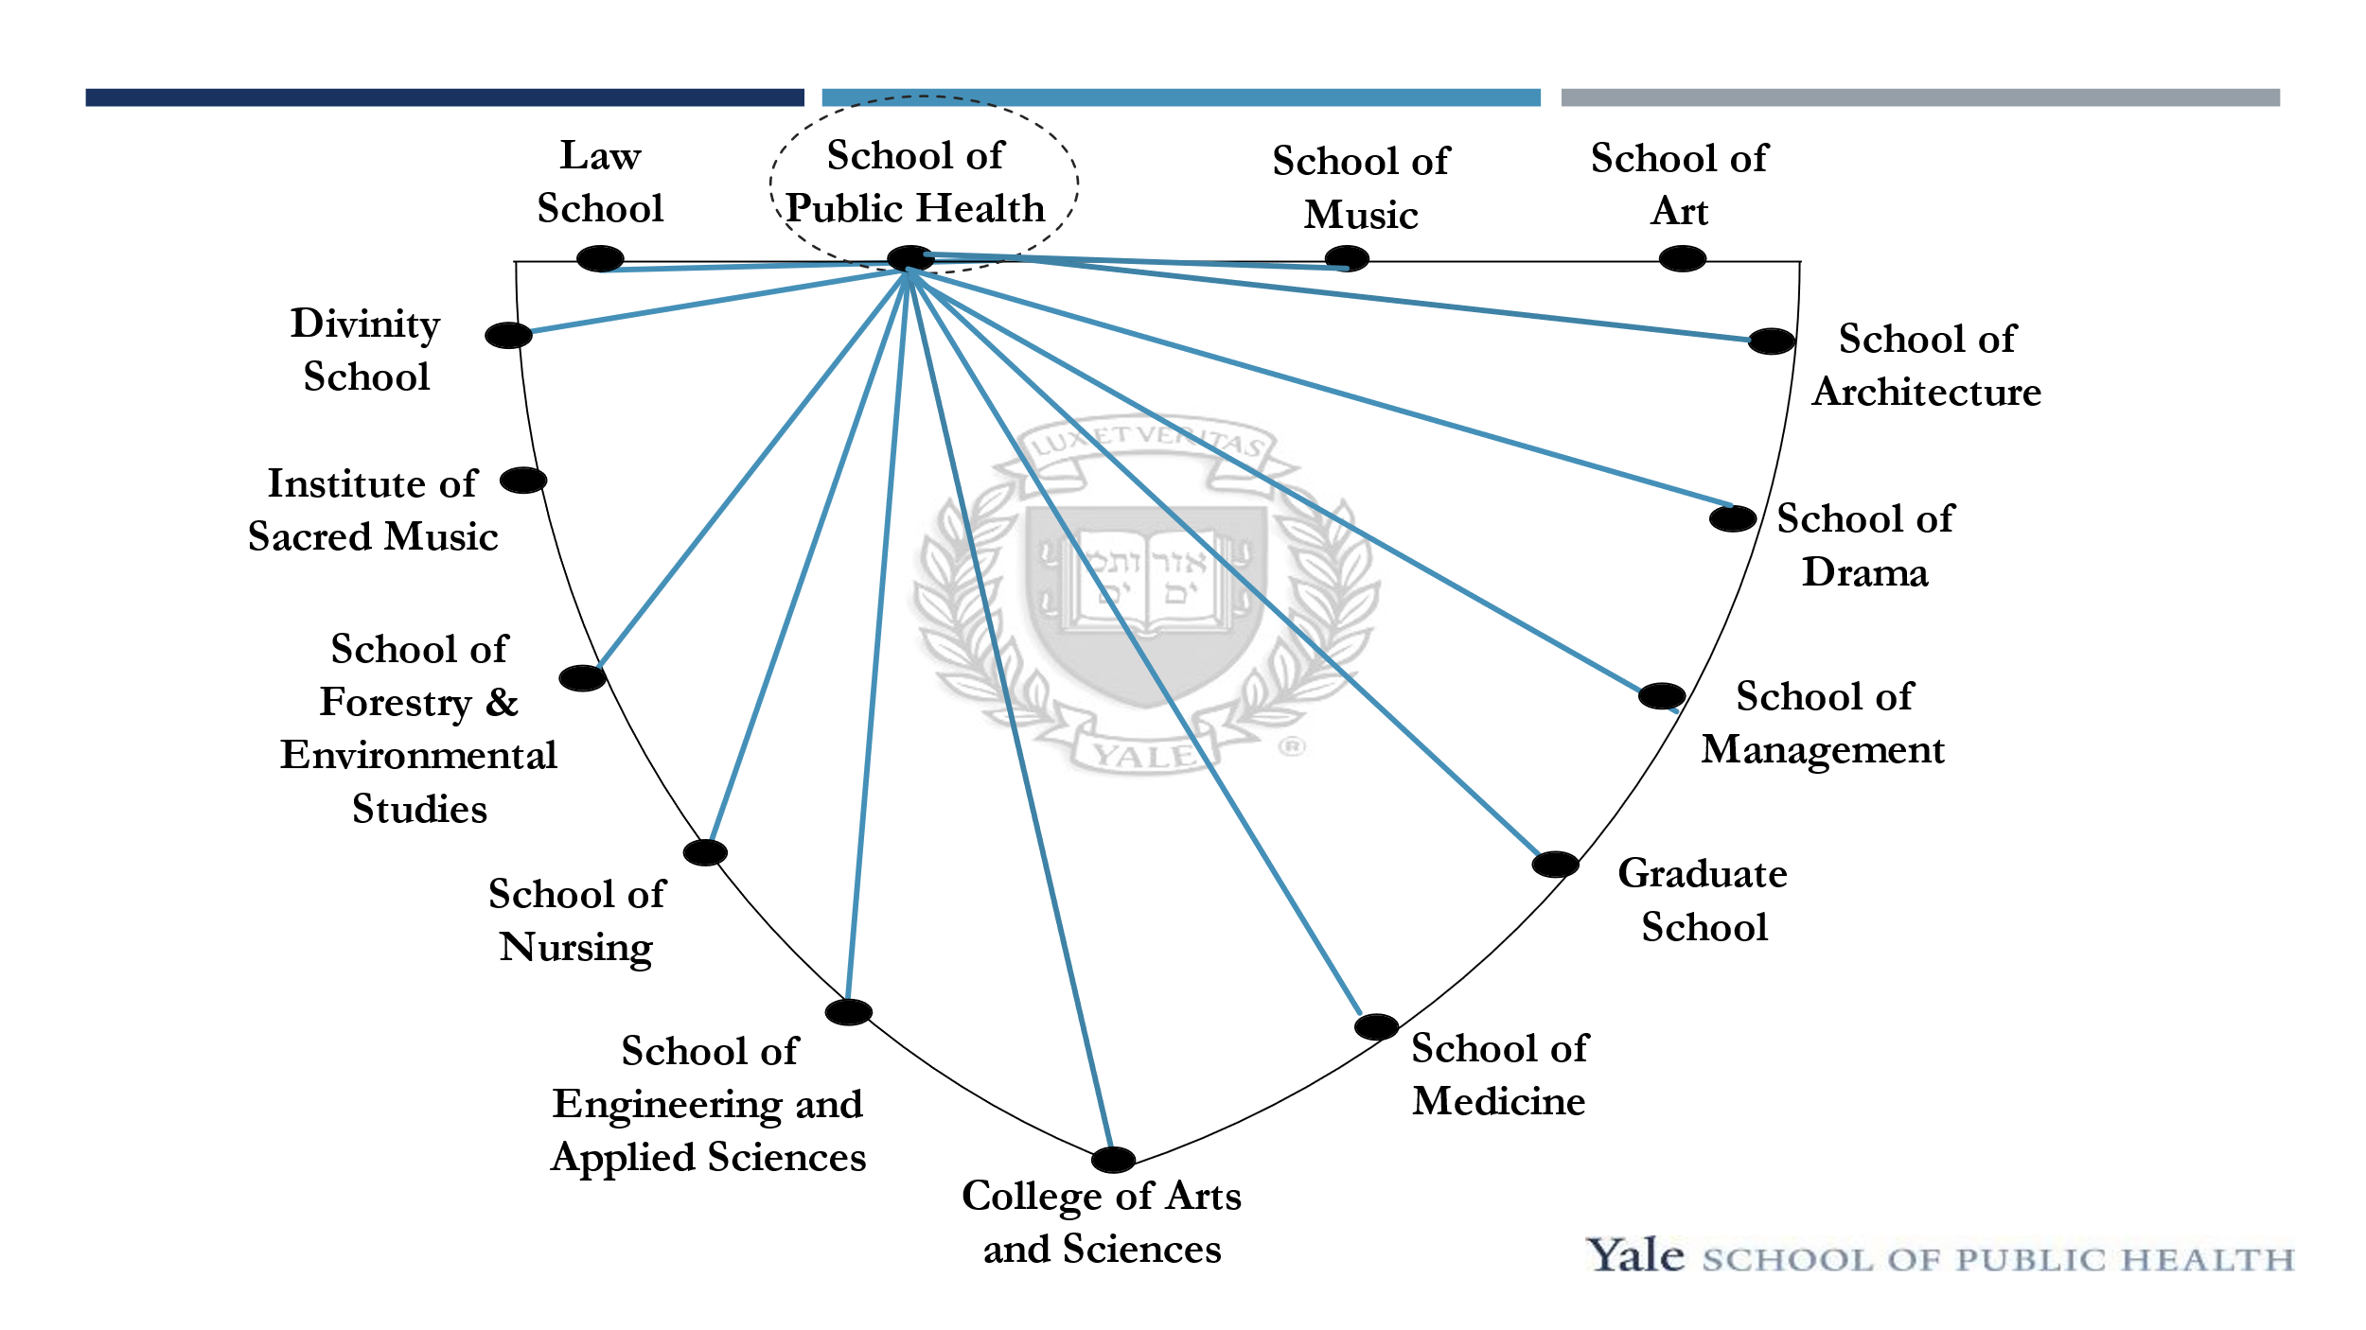

(14 graduate professional schools with approximately 8,000 students and

1 Yale College with approximately 6,500 students)

**A Troika of Public Health Crises in the U.S.**

By Elaine Gustafson, ’86 MSN

The Yale Club of the Suncoast was pleased to welcome Sten Vermund, MD, PhD former Dean of the Yale School of Public Health, as the keynote speaker for the Yale-Harvard-Princeton Luncheon held on February 10 at Michael’s On East. Dr. Vermund opened his remarks describing the School of Public Health and its connectivity to all other Yale professional schools (see figure above). The School of Public Health is the only Yale school that intersects with every other Yale school as well as Yale College. A priority at the YSPH is healthcare access. Dr. Vermund remarked that public health has improved in the U.S. due to the Affordable Care Act. Nonetheless, there are still about nine million citizens in the country without health insurance. Dr. Vermund explained that the public health of the future is a shared global responsibility, noting that climate change, cancer, obesity, healthcare access, population migration and partisanship in prevention of disease are all issues of great concern.

Preliminary remarks presented, Dr. Vermund moved on to the substance of his talk: “Public Health Challenges of the American Lifestyle: Guns, Pills and Sofas.” He began with a discussion of “sofas”, a euphemism for inactivity and its consequences, namely obesity. He traced the recent history of the obesity epidemic in the U.S. from the 1990s to present day highlighting the meteoric rise of obesity across the country with no state currently with less than 20% and several with greater than 40% (see figure below). Some of this rise is due to significant changes in dietary patterns with increased portion sizes and increased consumption of high sodium processed foods. Childhood obesity has also trended up based also on inactivity due to limited physical education and excessive screen time for children of all ages in addition to diets high in sugar, salt, and fat. Dr. Vermund explained that the food industry has some responsibility for the problem due to massive advertising of processed foods as well as initiatives involving sugar and salt that increase consumption.

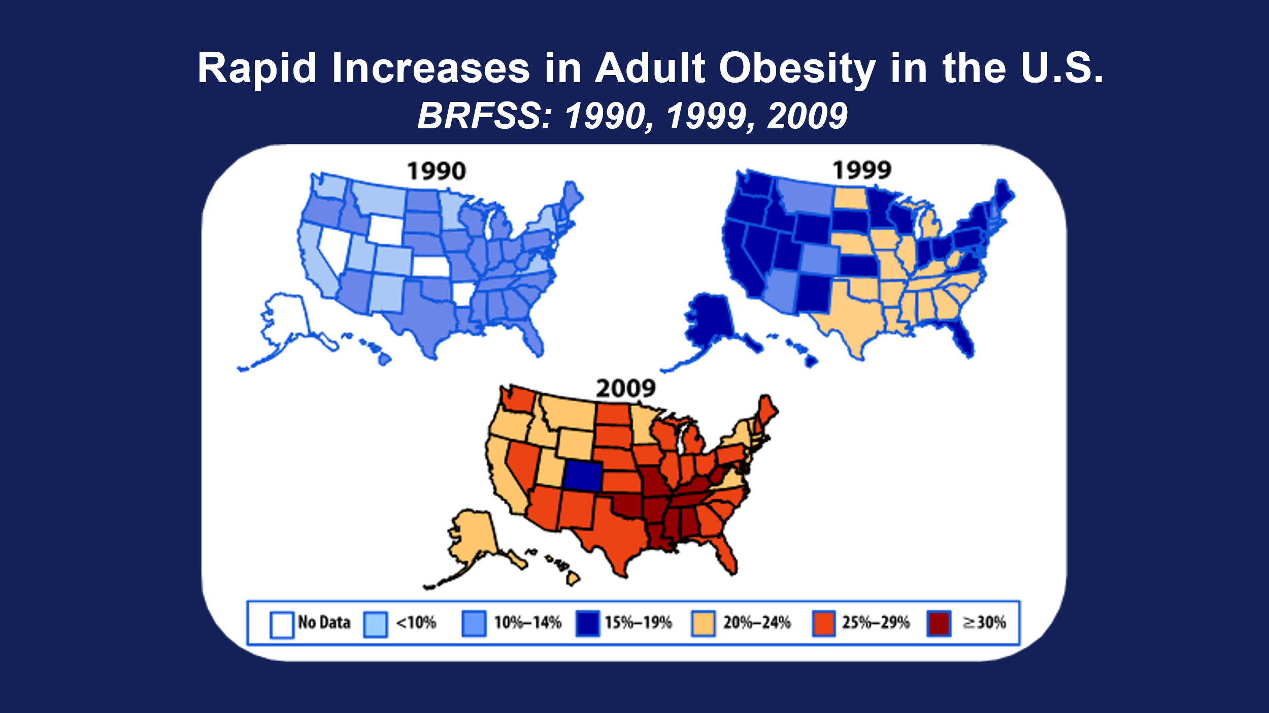

In part two of his presentation, Dr. Vermund gave an overview of the opioid epidemic in the U.S. and its horrific consequences. He mentioned that when he was in medical school in the 1970s there were about 400,000 people with opioid addiction, half residing in NYC compared to today with 2.4 million addicted with the number in NYC remaining about the same at 200,000. Overdose deaths have quadrupled since 1999, approaching one million. Drug overdose deaths are now the leading cause of injury deaths outstripping motor vehicle traffic accidents. Prescribers wrote more than 250 million opioid painkiller prescriptions in 2013 – enough for every adult in the United States. He emphasized that people who are addicted to opioid painkillers are 40 times more likely to become addicted to heroin and that the social and economic consequences are immense (see figure below). One in one hundred adult Americans are now addicted to opioids!

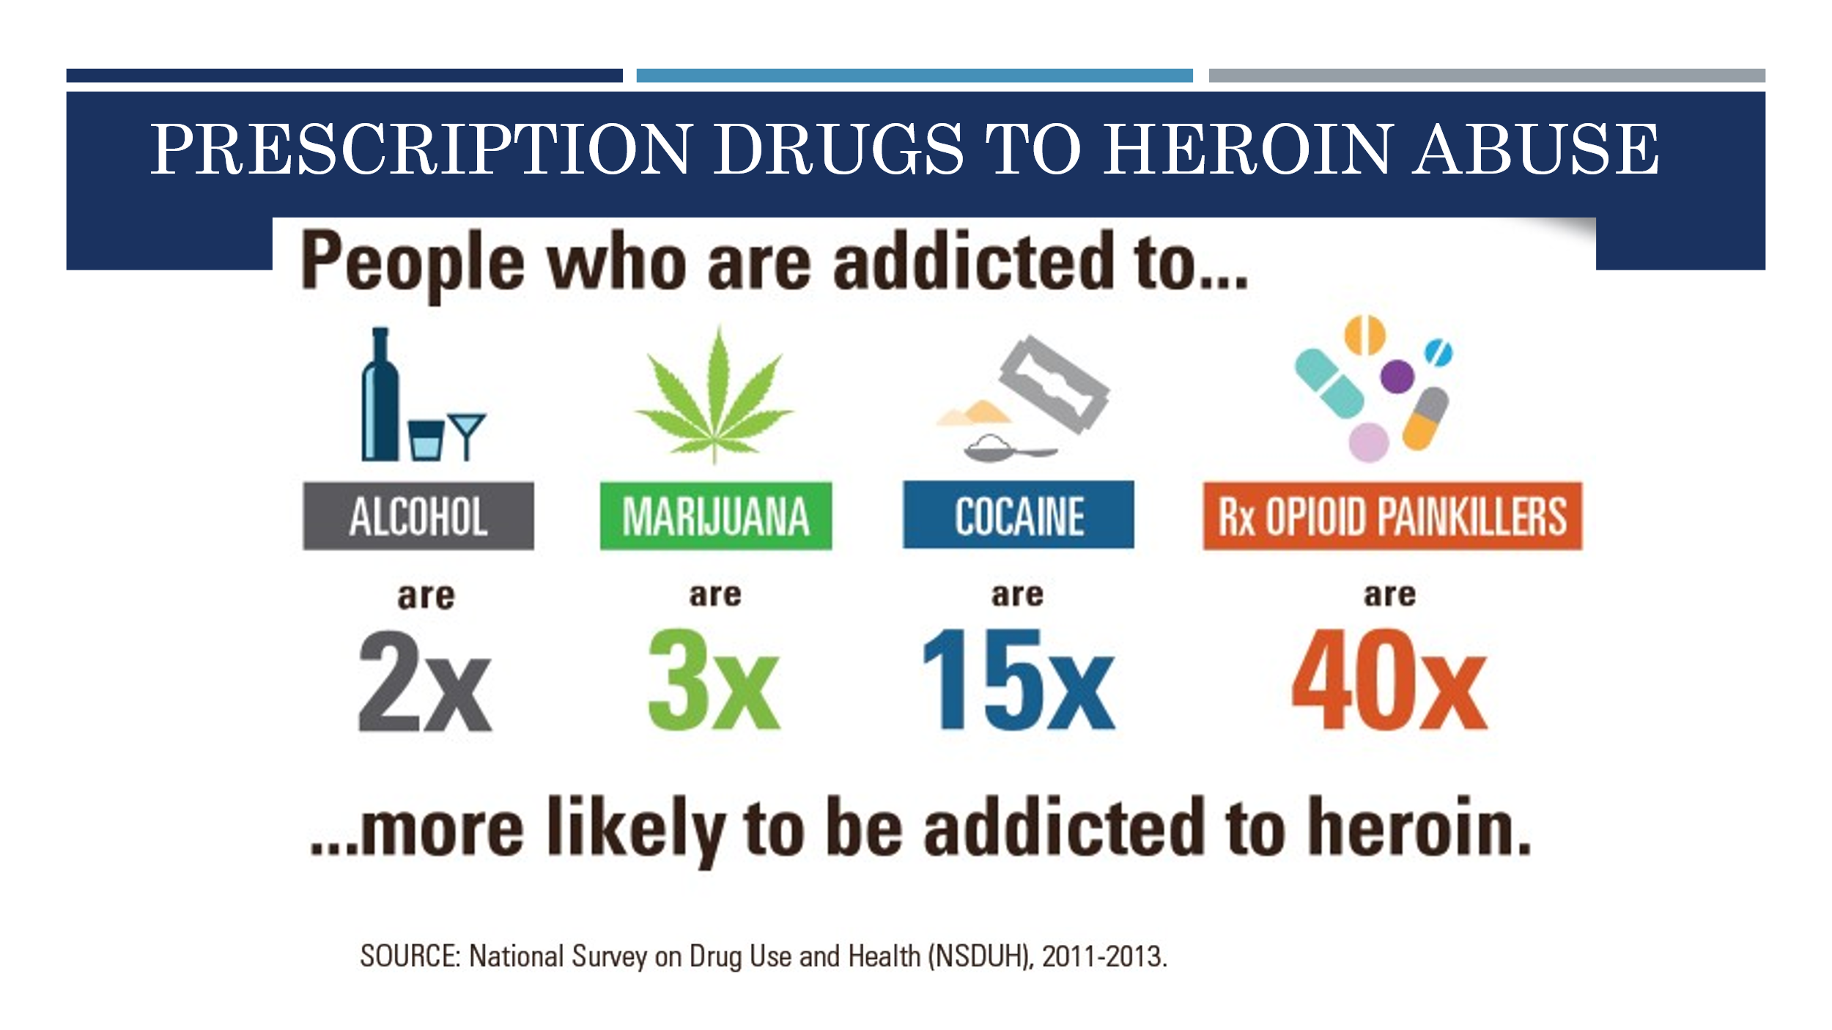

Concluding this section, Dr. Vermund briefly mentioned that we also now have a surge in vaccine hesitancy with the consequence that approximately 10% of COVID deaths are occurring in this unvaccinated population.

In the third and final part of his presentation, Dr. Vermund addressed the issue of gun violence. He began by sharing the AMA policy statement on Gun Violence: “With approximately 30,000 men, women and children dying each year at the barrel of a gun in … the United States faces a public health crisis of gun violence.” Twenty-two children and teens are shot every day in the US and 5-6 of them die each day. In all age groups there are 321 people shot daily and 111 die from their wounds. Causes of gunshot deaths vary from murder to suicide to accidental deaths. The numbers of guns in peoples’ possession has dramatically increased however the number of gun owners has not, meaning that the same number of people now have many more guns. There were an estimated 393 million guns in the US in 2022, 120 guns for every 100 persons. Of the annual US gun deaths more than 20,000 result in suicide and access to guns raises the risk of suicide because of their lethality. As to what to do about gun violence, Dr. Vermund posed many questions: Is there a possibility for political convergence to find a legal response to the problem? What about the links between mental illness, social isolation, and bullying? What is the role of policy: “Red flag” laws, waiting times, child storage requirements, restricted ownership, fingerprint usage and others?

Having invited discussion from the floor, a number of probing questions came from the assembly of approximately 110 alumni. When questioned specifically about the availability of mental health services for adolescents and young adults at university such as Yale, Dr. Vermund explained that there is a shortage of providers, from social workers to psychiatrists, across the country leaving many without desperately needed services.

Not a lot of hope on the immediate horizon, but nonetheless a great presentation by Dr. Vermund: clear, substantive, and timely.

**FINIS**