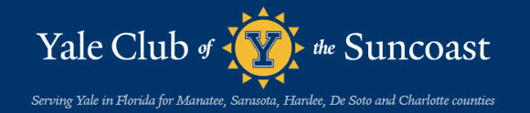
bluELInes: November, 2021
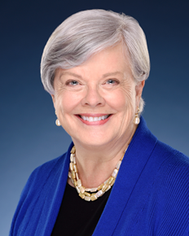
Elizabeth Spahn, President
Message from the President &
Membership Renewal Reminder Fall 2021
Dear Members of the Yale Club of the Suncoast Community
Wishing you all a very Happy Thanksgiving, and a speedy recovery from The Game (win or lose, some recovery is generally required in my experience).
This is a gentle reminder to renew your membership in our Yale Club of the Suncoast if you have not already done so. This link is for the form whether you are renewing or a new member.
https://www.memberplanet.com/s/yaleclubofthesuncoast/membershiprenewalapplication2019_2

Dues have remained constant for many years now – truly a bargain at $40 per year. Members receive discounts on all luncheons and events sponsored by the YCS, listing in our hard copy YCS Directory, and the heartfelt thanks of a hardworking Board who depend on membership dues to underwrite our Club’s activities.
Eligibility for membership extends to the entire family of our Yale community including spouses, parents, and grandparents. If you have any questions about the Club or membership, please feel free to contact our Membership Chair, Clarissa Moore at clarissa.petrino@gmail.com.
Any person who has been connected with any department of Yale University as a student or as an instructor, or who has received an honorary degree from the University, shall be eligible for membership in the association. Also eligible for membership shall be the surviving spouse of any deceased member and the parents and grandparents of current or past students at the University. (BY-LAWS, Yale Club of the Suncoast, Inc, Article II, Section I)
CLICK HERE TO JOIN/RENEW

Our speaker luncheons are held the second Tuesday of the month beginning in November and extending through May. The cost is $30/person for members. Yale affiliated non-members, non-member guests, and all walk-ins are $35/person. Other activities include Feb Club Emeritus, Yale Day of Service, the Marina Jack dinner cruise, a private tour of the Ringling Art Museum, and for the first time this year – an Orioles game at the ballpark with fellow Yalies.

2021 – 2022 Season
Saturday, November 20, 2021 –The Game. Yale/Harvard football game Watch Party at Raffulo’s 1818 Main Street together with our friends from that other university. Noon.

Tuesday, December 14, 2021 – Rick Piccolo, President and CEO of Sarasota Bradenton International Airport. Noon, at the Sarasota Yacht Club.

Tuesday, January 11, 2022 – Michael Morand ’87, ’93 MDiv, Beinecke Rare Book and Manuscript Library public relations and communications officer. Previously he was Associate Vice President of Yale for New Haven and State Affairs from 2000-2010. He will speak on the archives of American historian and sociologist W.E.B. Du Bois (1868–1963). Beginning with the Beinecke’s copy of Du Bois’s magnum opus, Black Reconstruction in America (1935), he will explore the James Weldon Johnson Memorial Collection of African American Arts and Letters, perhaps the top archive of its type at any university in the United States, named for the Florida-born writer and civil rights activist (1871–1938). Noon, Sarasota Yacht Club.

Sunday, January 16, 2022 – Welcome Back Cocktail Party, Sarasota Yacht Club 3:30 pm outdoors on the Lower Deck of the Sarasota Yacht Club, weather permitting. (Indoors in the event of poor weather.)

Monday, January 31, 2022 – 11:30 a.m. Tour the Hermitage with CEO Andy Sandburg, Yale ’05. Box lunch from Panera Bread with a resident artist who will share a few words about their Hermitage experience.

Friday, February 11, 2022 – Yale/Harvard/Princeton lunch at Michael’s on East, with a speaker provided by Princeton. Noon.

Tuesday, February 22, 2022 – Ringing Art Museum Tour followed by luncheon outdoors on the terrace at The Grill Room.

Sunday, March 6, 2022 – Yale Club trip to Baltimore Orioles/Tampa Bay Rays spring training game, potentially hosted by Mike Elias, Orioles General Manager and a Yalie.

Tuesday, March 9, 2022 – Yale professor to be named. Sarasota Yacht Club. Noon.

Sunday, April 10, 2022 – Sunset Dinner cruise departing from Marina Jack’s. Enjoy beautiful Sarasota Bay and our glorious Gulf sunsets with cocktails, a delicious dinner, and your fellow Yalies from Marina Jack’s luxury yacht.

Tuesday, April 12, 2022 –TBA. Sarasota Yacht Club, noon.

We hope you will decide to join the Yale Club of the Suncoast as a full member, and we look forward to greeting you in person at one of our events in the near future.

Boola!

Elizabeth Spahn, ‘72
President, Yale Club of the Suncoast
*****
“Returning to Sarasota”
By Trudy Mulvey
It doesn't seem possible that summer is over and we are into November. For those of us who don't live in Sarasota full time, it feels so comfortable to return home to this beautiful state with all of the available opportunities to enjoy the Arts and Entertainment so readily accessible to all, and the outstanding beauty of the environment. I'm confident many of you have seen or heard about Sarasota's recognition by both Time Magazine as one of the World's 100 Greatest Places to live in 2021, and US News and World Report as the number 1 Best Place to Retire, and number 16 on the list of Best Places to Live in the U.S. How fitting that we are also celebrating our centennial year.
Mr. Brad Jaffe, from Time Magazine, describes Sarasota "as proving itself a vital cultural capital". As examples he noted the Sarasota Art Museum, The Bay, the upgraded Lido Beach Pavilion, and the Resort at Longboat Key Club as major areas of interest in the area.
The US News and World Report criteria for selection as a retirement community
included health care quality, retiree taxes, desirability, job market ratings, and happiness measure. Also mentioned were our beaches, shops, cultural attractions, and restaurants.
We have 35 miles of beaches in Sarasota, and Siesta Key has received recognition
as one of the best beaches in America by Trip Advisor and Dr. Beach. The beach is 99% pure quartz crystals which feel lovely in the heat of the day. No burning feet is a very enjoyable treat with no calories.
Covid 19 restrictions have changed the way we socialize and relax outdoors, so
beaches have become a natural place to relax and socially distance ourselves. We can also exercise and enjoy the natural beauty. My favorite spot to relax, enjoy nature, beauty, and fantastic sunsets is Longboat Key. Check out our interview with Mayor Ken Schneier (’74) below. There are so many wonderful choices for theatre, opera, symphony orchestra, and ballet to name some cultural options. The restaurants are another area where we have so many different choices and types, it's also different to decide. Museums, art galleries, educational offerings, parks, sports, fishing, and many other activities too numerous to mention complement these to make Sarasota a beautiful spot to call home. I look forward to our Yale Club and the activities that will be available to us this 2021-2022 season. Welcome back! I’m eager to see you.

*****
“Yale Club’s Drop-In Lunches Continued through the Summer Season”
By Oliver Janney
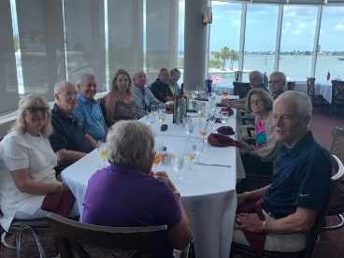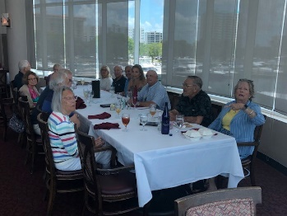
28 members kicked off the summer drop-in luncheons on the outside deck at Marina Jack’s on May 11th. All enjoyed our first in-person event in over a year on a beautiful breezy afternoon. The numbers stayed up for the lunches indoors in June and July. While fewer members attended the August and September lunches, those who attended enjoyed delightful fellowship with new members.

*****
“Alumni Fellow Election: What’s All the Fuss About?”
By Craig Wright
“Outraged and Offended: Yale Corporation Cuts Alumni Petition Process,” screamed a May 25 headline in America’s oldest college newspaper.
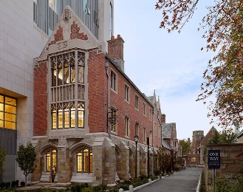
Offices of America’s oldest college newspaper
“Darkness at Yale” proclaimed The Wall Street Journal on June 3. In the latter piece, Yale alumni, lawyer, and political operative Lanny J. Davis wrote: “Yale’s Latin motto is “Lux et Veritas”: “Light and Truth.” Yet the Yale Board of Trustees has acted in a way contradicting these two important values. The board’s May 24 [sic] decision to eliminate trustee nominations by alumni petition outside the board’s own processes is contrary to good corporate-governance principles, which aim to give all stakeholders a voice.”
Had the administration of Peter Salovey managed to suppress dissent at Yale, and possibly extend his own tenure through control of the Board of Trustees? Had the Trustees engineered a way to stifle dissent and perpetuate an exclusionary vision of what Yale should be? Or was all this noise merely a “tempest in a teapot” owing to misunderstanding about how members the Board of Trustees come to assume their positions?
Let’s back up and try to set an historical context. Yale University is governed by The Corporation, a board of trustees that includes the president of the university and sixteen Yale graduates. Ten successor trustees are appointed by the board and six alumni fellows are elected by the alumni as vacancies occur. Compared to benchmark institutions, such as Princeton and Cornell, the percentage of alumni seats on the Yale Board of Trustees is exceptionally high. The alumni trustees are called alumni fellows. So how are the alumni trustees/fellows selected?
In 1929, the Yale Corporation created two paths to the ballot: selection of candidates by the predecessor of the Yale Alumni Association (YAA); and a petition process allowing direct ballot access for those alumni who gathered a prescribed number of signatures. Let’s dig into these two processes a bit deeper.
Process No. 1: Within the Yale Alumni Association Board of Governors rests an Alumni Fellow Nominating Committee, made up primarily of volunteer alumni leaders, most of whom also serve on the YAA’s Board of Governors. How are candidates chosen?
“The Committee shall solicit candidate recommendations from members of the YAA Assembly, duly-elected leaders of constituencies entitled to representation on the YAA Assemblies (classes, clubs, the Graduate School and professional schools’ alumni associations, and the senior class of Yale College), and other such groups as the Committee deems appropriate.”
Process No. 2: An outside petition process, again, allows “direct ballot access to alumni who gather a prescribed number of signatures.” Since 1950 the petition process had been used, according to a Yale Corporation memo of 2021, only intermittently, often in short bursts over a few years and often by a particular person or group.

Over an unspecified period of time, the Board of Trustees came to view the petition process as unhelpful, and on May 18, 2021, voted to eliminate it. The decision of the Board was announced by Senior Trustee on Catherine Bond Hill to the Alumni in a letter of Mary 24.

“After careful consideration over the last few years, the Board of Trustees has determined that the petition process to become a candidate in the Alumni Fellow election no longer serves the best interests of the university, and it has voted to amend the university’s Miscellaneous Regulations to remove this path to candidacy, effective immediately.”

In an amicus curiae letter of May 31, 2021, former trustee and University Secretary Linda Lorimer, wrote: “The petition process was inconsistent with these fundamental tenets of best practices in the governance of higher education. Having special “interest candidates” . . . was antithetical to the notion of having trustees who were there first and foremost to serve the entire welfare of the university.”
It appears that’s there’s the rub—"special interest candidates.” Here things get dicey: Is not one person’s special interest another person’s path to truth and enlightenment (Lux et veritas)? That’s for each person to decide.
But for the moment, here’s where we stand: Process No. 2 has been removed from the operating procedures of the Yale Corporation. The power to nominate candidates for the Board of Trustees rests solely in the hands of the Alumni Fellow Nominating Committee, a subset of the Yale Alumni Association Board.
Nevertheless, we all continue to receive periodic emails from one Gail Lavielle urging us to sign a petition directing the Alumni Fellow Nominating Committee “to take a step toward righting the Yale Corporation's error eliminating the petition process for trustee candidates.” To sign or not to sign? Special interests or public servants? Again, it’s your call. But that’s where we stand.
(Corrections, objections, clarifications, and further information are welcomed by your editors.)
*****
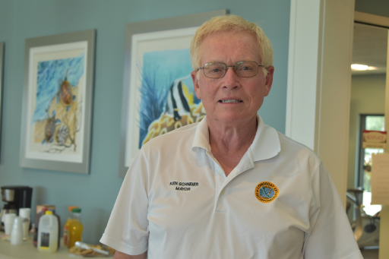
“Yalie and Problem Solver:
An Interview of Ken Schneier (’74), Mayor of Longboat Key”

By Trudy Mulvey

You may know of Ken Schneier from The Yale Club of the Suncoast, of which he was President from 2015-2017; you may know him as the Mayor of Longboat Key; or perhaps you knew him at Yale. But whatever the context in which you know Ken, you’ll be struct by his intelligence, modesty, sense of humor, and unfailing dedication to public service. We were fortunate to enlist Ken's cooperation in writing this article about his experiences from high school to his role as Mayor of Longboat Key. We submitted eight questions, and these are his responses.

Number 1- Has a political career always been an interest of yours?
Answer- "No. My last experience was as President of our high school student council,
a job from which I was unceremoniously removed by a nasty principal for engineering
a protest against school dress code and final exam policies. The removal led to a walkout (on a beautiful spring day) which was not my fault but led to a massive hullaballoo in our town, which led to the (ceremonious) removal of said principal. Cured me of politics for 48 years".

Number 2-How do you feel your education prepared you for this role?
Answer-" I was second tenor in Alley Cats, which taught me how to appear before an
audience".

Number 3- What advice would you offer someone, a Yale undergraduate for example, who expressed an interest in a political career?
Answer- "For a variety of reasons, personal and public, make your fortune first if that is important to you."

Number 4- Have you had a mentor before, while you were at Yale or later, that helped
prepare you for your experience as Mayor?
Answer- "No. If I had, I wouldn't be in a full-time unpaid job where people call me to say their garbage wasn't picked up (in fairness, this only happened once)."

Number 5-What is the most surprising/interesting event that shaped your career?
Answer- "My careers in law/business and in Town politics actually segued in unplanned
but logical steps. Having retired abruptly in 2009, we moved to Longboat Key with no program in mind. For me, openings on the Zoning Board of Adjustment, followed by the planning Board, followed by the Town Commission presented themselves as I felt qualified to handle them. The seven members of the Commission elect a mayor each year. I was a chosen for that role after two years on the Commission and am finishing my second term as Mayor. The only real surprise in my career was that I ended up working in New York City for 20 years after vowing never to do so.

Number 6- You have already accomplished a good deal as Mayor: Dealt skillfully with an environmental issue no fault of the town; overseen completion of a large, new firehouse cum public emergency shelter; shepherded through to approval a 3/4 billion dollar new hotel/condo project; and initiated plans for a new town center. What do you find the best and worst aspects of your job.
Answer- “I hesitate to dim your good impression of me by saying anymore, but I've always been a news junkie and problem solver and this job is a great opportunity for both. Because we have an excellent town staff, there are very few negative aspects to the position, except maybe getting 300-700 pages of material to review on a Thursday for a Monday meeting."

Number 7- How has this experience enriched your life?
Answer- "I actually love it. Our town manager, the former administrator for all Sarasota County, is one of the best people I have ever worked with. He and the great people who run our various departments make the job easy and let us focus on the policy issues. It is MUCH easier than being President of the Yale Club of the Suncoast, where the buck truly stops there."

Number 8- How do you feel you have affected change on Longboat Key?
Answer- "I am one vote of seven, so my personal efforts haven't been material in effective change. I see my role as setting the tone for the town and driving our agenda to get done what needs to get done. This includes "keeping the lights on"--and all the little things that make life work for our citizens. It also includes driving the major projects that improve the town, like the St. Regis, the undergrounding of all utilities to be completed next year, and the $40 million beach renourishment project that was just finished. Finally, and somewhat ironically, on Longboat Key all this must be done without changing the character of the community. All challenging, but rewarding."

*****
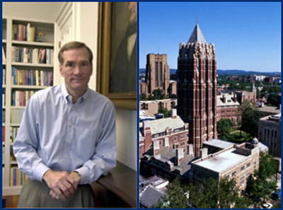
The late David Swensen, Chief Investment Officer, and the newly named Swensen Tower
“About David Swensen: One More Story and One Last Win”
By Craig Wright
Who is the most important person in the history of Yale University? My vote goes to David Swensen. During his thirty-six year tenure as Chief Investment Officer at Yale, David Swensen took the University endowment from something around 1 billion dollars to more than 42 billion today. With the returns on that money, the campus was re-built and the city of New Haven rejuvenated—both were something of a mess when I and, later my wife, Sherry came to New Haven during the 1970s. Today the mandated 5.2% annual payout on the returns the endowment pays for about two-thirds of the University’s bills (Faculty of Arts and Sciences). Not without reason did Bloomberg Businessweek titled an article in 2019: “How David Swensen Made Yale Fabulously Rich.”
But with Swensen, who died this summer after more than decade-long battle with cancer, it wasn’t about the money—it really wasn’t. Yes, he was the highest paid employee at Yale, but by my estimate he was earning about 4% of what he could have been pulling in annually on Wall Street, which he walked away from in 1985. And a good chunk of what David was paid he gave back to Yale by endowing scholarships. He gave back in other ways too.
There have been many obituaries of for David Swensen, not the least of which the frontpage pieces in The New York Times and the Wall Street Journal. The most insightful Swensen tribute, however, was perhaps the cover story of the July/August Yale Alumni Magazine, which included recollections by President Peter Salovey, former President Richard Levin, and David Swensen’s long-time investment partner at Yale, Dean Takahashi. There was also a tribute by Mark Brach on “Coach Dave,” that discussed Swensen as a coach in a boys’ youth soccer program. What has gone unmentioned, is that David was an equal opportunity coach, not just coaching but organizing and running a girls’ 12-and-under team. On this girls’ team, David was the coach, and I the water boy for the players and babysitter for their younger siblings—so I spent a lot of time watching.
Perhaps as with playing golf, so with coaching: You can learn much about a person’s character by observing how they behave when few are noticing yet winning is important. And yes, David liked to win. Our paths occasionally crossed on the tennis court and one or twice at the Yale golf course, and it was clear that be it tennis, golf, soccer, or managing Yale’s money, for David Swensen winning was important. But that’s not what drove him.
Among Coach Dave’s rules for life were the following: Players were selected for the team without prejudice regarding ability—we were all in this together. All players got the same amount of instruction and encouragement, and--most challenging for a coach who likes to win—the same amount of playing time.
One story, which perhaps only my wife and I remember, says it all. During a tight game, one girl stole the ball at mid-field, raced toward the net, and scored. The only problem was she had gotten confused and had kicked the ball into her own team’s goal. The fans were laughing, her teammates angry, and the girl mortified. How would her coach react? As she (in truth our daughter) came over to the sidelines, Coach Dave walked out to the field. He put his arm around her and said loudly for all to hear: “Stephanie, Stephanie, good for you, I had no idea that you could run so fast!”
David Swensen left Yale a lot of money, but this and similar “Swensen stories” show how he touched a lot of lives and gave the University something else: a strong moral compass.
Post scriptum: The return on Yale’s endowment for fiscal 2021 was 40.2%, which grew the fund from $31.2 to $42.3 billion. (Two points to keep in mind: 1) again, when Swensen started, the Yale endowment was about one billion; and 2) the endowment is required to “pay back” to the university about half its value every ten years.) This final win for “Coach Dave” was a big one. Requiescat in pace.
FINIS

