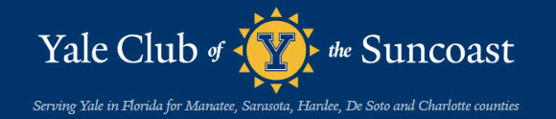
bluELInes: January 2022

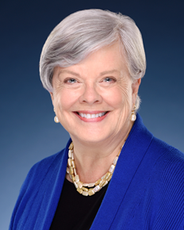
Elizabeth Spahn, President

President’s Message January 2022

As the season kicks off, we are still struggling with how best to proceed during yet another wave of Covid. The Yale Club of the Suncoast Board of Directors has steered a middle path to ensure the health and safety of our members, while continuing our in-person gatherings. (Our efforts to meet via Zoom last year, frankly, were sparsely attended by members. I suspect many of us are less tech-savvy than Yale undergrads.) The Board is doing its best to keep our YCS community healthy and active. Any mistakes are mine alone. Feel free to email me with suggestions. elizabeth.spahn@gmail.com
Our YCS membership renewal drive, led by Brian Kelly and his Magnificent Seven, was highly successful. The YCS Directory including all our current members up-to-date contact information is finished and will be mailed to members very soon. Thank you to all who renewed or joined as dues-paying members. The Club would not be able to host our programs without these contributions to our reserves.
Outdoor events are our focus this year. Taking full advantage of our beautiful Suncoast weather and scenery, we hope that outdoors is also safer for all of us. We will continue to follow the Sarasota area Arts Communities protocols requiring proof of either a recent negative Covid test or vaccination until the Board decides it is no longer necessary.

Our website https://yaleclubofthesuncoast.org/events/ will keep you up to date with all our events including any last- minute changes.

The January 11th luncheon at the Sarasota Yacht Club brought our first Yale speaker, Michael Morand, Communications Director of the Beinecke Library. He discussed one of the jewels of the Beinecke Library - the James Weldon Johnson Memorial Collection of African American Arts and Letters (see report below). One of the nation’s top archives of African Americana, the collection is named for the Florida-born writer and civil rights activist (1871–1938).

January 16th saw our postponed Welcome Back Party at the Sarasota Yacht Club from 3:30 – 5:30 pm (again, see report below). We moved the event indoors due to unusual bad weather. We toasted the New Year with cocktails and hors d’oeuvres to the sounds of classical guitar music as the sun set over our lovely Sarasota Bay.

January 31st we have a private tour and outdoor lunch at The Hermitage Artists’ Retreat, led by our own Tony Award winning Andy Sandberg, ’05 (Whiffenpoof), Artistic Director and CEO. There is a tip from a credible source that one of the Hermitage artists may also join us.

February 11th Princeton will host the joint Yale/Harvard/Princeton at Michael’s on East. The speaker will be David W. Miller, Director of the Faith and Work Initiative at Princeton’s Keller Center for Innovation in Engineering Education.

February 25th our first joint event with the Naples/ Ft. Myers Yale Club also serves as our Feb Club Emeritus event, outdoors with libations. Time & location will be announced soon.

March 6th we have seats in the shade for the Orioles / Rays baseball game (assuming the lockout is over). With luck General Manager Mark Elias, ’06 will be able to join us.

Note the change of date for our March Luncheon. It is moved to March 23rd to accommodate the teaching schedule of our second Yale speaker of the season. Yale Law Professor Akhil Reed Amar is one of the most dynamic professors on the Yale speaking circuits and his visit to Sarasota several years ago was very well received.

April 10th is the highlight of our social season - The Dinner Cruise on Marina Jack’s private yacht. We guarantee plenty of fresh, clean Sarasota Bay air, as well as delicious food and drink.

April 12th an expert from USF on local Sarasota area water quality including red tide and toxic spills will speak at our Yacht Club luncheon.

May 10th will wrap up our season with the popular farewell luncheon outside on the deck at Marina Jacks where we enjoy conversing with our fellow Yale Club members. I think of this as the “Dorothy Parker and the Algonquin Club” event (or a typical lunch in the dining halls at Yale). Sharpen your wits and enjoy chatting with our very interesting membership.

Thank you to all the true blue Yalies, family members, and friends who support the YCS through thick and thin. Thanks also to the extremely hard- working Board members.

Our Yale community demonstrates that persistence and compromise can succeed in holding our community together even in these challenging times.

Boola,
Elizabeth Spahn, ‘72

P.S. Here is your Yale musical treat to start off 2022 in hope for a healthier, calmer year. This special Commencement 2021 performance of the Yale Glee Club was recorded on May 12, 2021, in the courtyard of Timothy Dwight College. Glee Club members came together in person for the first time in over a year. Seeing these gifted, beautiful young Yalies singing their hearts out despite their bright college years spent in the shadow of this pandemic gives me determination. And resilience.

https://youtu.be/DmuVlgEwpBg


*****
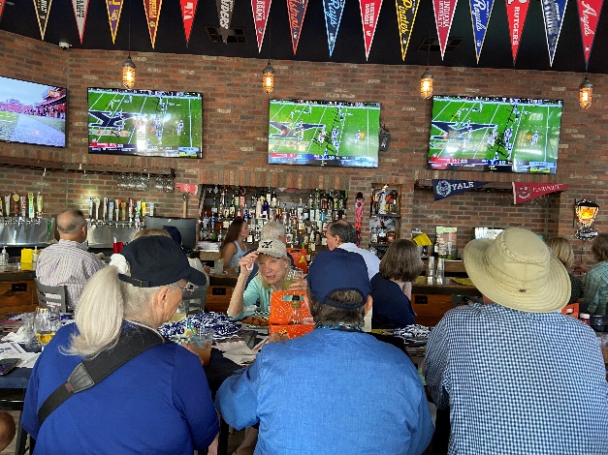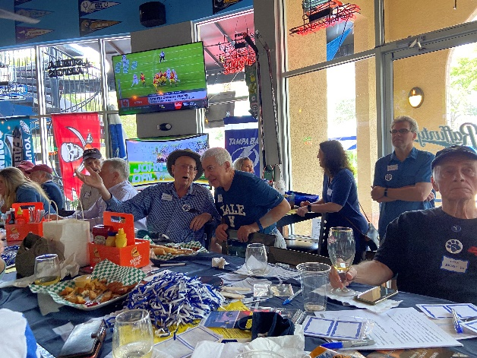
Yalies admitted to the bar. “Don’t Look Up”

“THE Game: We Were Ahead . . . .”
By Staff Sports Unit

We were ahead. We were behind. We were ahead. We had almost won it. Then we lost it. The Game 2021 mirrored the rollercoaster ride of the year itself. With 22 seconds left, the other school scored, and we lost, 34-31.
Here is the link to the Yale Daily News article with play- by- play information and the names and numbers of all the players. https://yaledailynews.com/blog/2021/11/20/football-halftime-yale-trails-harvard-20-17-behind-nolan-grooms-150-passing-yards-and-two-touchdown-passes/
The Yale Club of the Suncoast gathered with friendly folks from the other place at Raffurty’s Bar & Grill on Main Street. We had a great turnout – more than 30 Yalies showed up. At least we beat Harvard in attendance. YAA sent a box of Yale swag, so we had pom poms, buttons, and stickers. Raffurty’s kept us lubricated and fed. It was fun, except for that ending. Oh well. Next year.
*****
“The Yale Interview Process:
Admissions 2021”
By Patrick Whelan
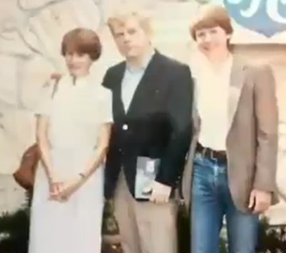
Patrick Whelan, current director of the Suncoast Yale Club’s Alumni Schools Committee, at his first Yale Club luncheon in April 1984. Accompanied by his parents, Patrick had just recently been accepted to Yale.

My first encounter with the Yale Club of the Suncoast occurred in 1984 when I was a high school senior going through the college application process. I do not remember my Yale interview, but I do remember the hospitality extended to me at my first Yale Club luncheon in April 1984.
Appropriately, now I help serve Yale through the same Alumni Schools Committee that sent me to New Haven. I direct a group of highly dedicated club members who promote Yale University within the community and interview applicants as part of the admissions process.
Yale admissions has become astoundingly competitive. For the 2021 admissions season only 6.9% of applicants were accepted. Given the high selective nature of admissions, the interviews conducted by our alumni volunteers are critically important for helping the admissions committee make their decisions. Over the past several years, the admissions rate for our area has been in line with the global averages for Yale. Our yield rate, however, has been higher. If a local student is admitted to Yale, he or she is very likely to matriculate and attend.
For last year’s Class of 2025 we had 87 applicants from 19 schools covering an area that includes Sarasota and Manatee Counties together with smaller surrounding rural counties. Of those, 21 applicants applied as part of Yale’s single-choice early action program. Last year three students were accepted and now attend Yale. For the Yale Class of 2026, our early action program had 17 applicants out of a total of 86 applicants from 20 high schools; so far two students have been accepted early.
Our volunteers also present book awards to rising seniors at local high schools. School personnel nominate one student from each school who displays outstanding personal character and intellectual promise to receive The Yale Book of Quotations. Many local university clubs provide book awards, but none reaches out to more high schools than our Yale Club. For many local high schools that are underrepresented in competitive college admissions, the Yale Book Award is the only college book award at their school and the highest honor that a junior can receive. In the early summer we invite all of our recipients together with their families to a reception, which functions both as a recognition for their achievement and a chance for us to promote Yale to the best and the brightest.
For the past two admissions seasons, the twelve members of our club’s Alumni Schools Committee have interviewed students through video conferences. Even with this limitation, we have made deep connections with prospective students. Every year I hear how grateful the admissions representatives are of the work that we do. Our club has the reputation of providing extremely high quality reports.

If you would like to learn more about the Yale Club of the Suncoast’s Alumni Schools Committee, contact Patrick Whelan at notableoak@msn.com or 941-932-0334.

*****
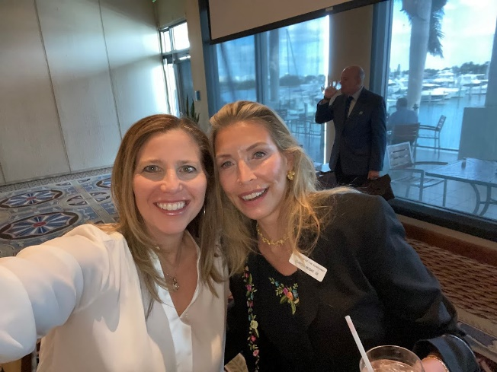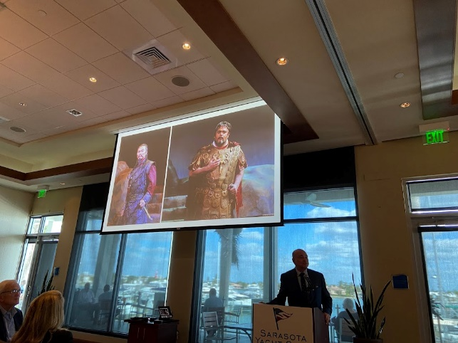
Board Members Hedi Katz and Clarissa Moore with Richard Russell at the Podium and Rigoletto types

“Presentation by Richard Russell, General Director of Sarasota Opera”
Sarasota Yacht Club November 9, 2021
By Edward V. Williams

Elizabeth Spahn, President of the Yale Club of the Suncoast, opened the luncheon meeting on November 9, 2021, with a warm welcome to all members at the club’s return to the Sarasota Yacht Club, its first in-person meeting there since March 9, 2020. Because of Veterans Day on November 11, Elizabeth acknowledged the national service by the club’s military veterans and from those who had served in government positions by asking them to rise and be recognized. She also expressed her appreciation to two of the Yale Club’s past presidents, Elaine Gustafson and Rick Lannamann and called on Rick to introduce the speaker, Richard Russell, General Director of Sarasota Opera.
Hired twenty-one years ago by Maestro Victor DiRenzi, Mr. Russell began his informative presentation on Sarasota Opera by stating that his background for the administrative position he holds combines his experience as a concert and opera singer and his career as a banker in New York. He first came to Sarasota Opera as a tenor in the company’s Apprentice Artists Program and later returned to serve as Marketing Manager. Throughout his presentation Mr. Russell conveyed his dedication to his responsibilities as General Director and his enthusiasm as a spokesman for Sarasota Opera.
Projecting texts and images on the two screens, Mr. Russell disclosed several facts about Sarasota Opera that may not be well known. He pointed out that the company is the only opera company in the United States to have offered in-theater performances for socially-distanced and masked audiences during the 2021 winter opera season. Sarasota Opera, the largest opera company in the southeast, is one of nine companies in the country performing in a theater it owns. In addition, the company’s Youth Opera is the only such program in the United States whose young singers perform on the company’s main stage.
Screening several photos of the Opera House, Mr. Russell traced the building’s history from its opening as the Edwards Theater in 1926 to the present. Sarasota Opera purchased the Edwards Theater in 1979, followed by a renovation in 1984. At one time the building’s façade carried the name Sarasota Theater of the Arts, the word “Arts” considered more effective in drawing larger audiences. Private donors funded the more recent and extensive renovations of the Opera House in 2007 and early 2008. Other initiatives include an Education and Outreach Program and the summer Film Series, which screens classic motion pictures and productions of the performing arts.
Mr. Russell cited several singular achievements of Artistic Director Victor DiRenzi, the only opera director to have conducted all of Verdi’s operas and presented in concert each of the composer’s other compositions. Maestro DiRenzi also initiated the company’s two programs for Apprentice Artists and for Studio Artists. These young singers, mostly American-based, perform in productions’ smaller roles, understudy the principal roles, and participate in outreach performances in schools and the community (e.g., Sarasota’s university clubs). For the fall season with its single opera, musicians from the Sarasota Orchestra comprise the pit orchestra. For the winter season’s orchestra, however, musicians are contracted mostly from outside the local area. Many of them return year after year and thus provide continuity and stability for the company’s productions.
During the winter season of 2021, shorter operas were presented without intermissions and with social distancing and masks required for audiences in the Opera House. To protect artists in the Opera House and in their nearby residences, the management created a safety bubble for them and instituted appropriate protocols. Outside of opera seasons, the forty-six residences for artists that the company owns are rented to other non-profit organizations to generate additional revenue.
Mr. Russell mentioned that the company’s business and financial issues are overseen by a Board of Trustees and that generous donors provide 50% of the company’s income. Sarasota Opera’s total income during a normal season is about $8,600,000 with overall expenses totaling some $100,000 less. The recent purchase of an extensive collection of historic costumes from Malabar in Toronto will save $100,000 annually in costume rentals. Since 1923 Malabar has been the leading supplier of costumes for opera companies, particularly for mid-level companies in the United States.
Pointing to Sarasota’s numerous arts organizations, Mr. Russell stated that together these organizations comprise the second largest employer in Sarasota County and generate $342M annually in the Sarasota-Manatee area. Each of the performing arts, however, has been financially decimated by the pandemic. Sarasota Opera cancelled its fall season in 2020 but supported two outdoor and two indoor concerts. Ticket sales for the four short operas staged during the winter season of 2021 generated only $400K compared to $3M during a normal winter season. Generous donors stepped in to provide funding to fill the deficit. The Youth Opera continued to meet during 2020-2021 through virtual means.
The performing arts in Sarasota have proven to be a major national and international tourist attraction. In a normal year 52% of Sarasota Opera’s patrons are from Sarasota County, 15% from Manatee County, 9% from elsewhere in Florida, 22% from other states, and 2% from other countries. Finally, Mr. Russell stated that the fall 2021 season, offering Rossini’s Silken Ladder, will be followed by the usual four, multi-act operas during the winter season of 2022. This forthcoming season, however, will be shortened by a week and will offer fewer performances of each opera. Members of the Youth Opera will perform in person but on a more limited scale.
Mr. Russell then invited questions from Yale Club members and responded with details concerning storage facilities for the costume collection; vaccine mandates for artists, crew, and audiences; and the company’s library of vocal and orchestral scores and instrumental parts. Club members expressed their appreciation to Mr. Russell with hearty applause for his informative and articulate overview of Sarasota Opera. Elizabeth Spahn thanked him as well and presented a Yale souvenir, which concluded the luncheon.

*****

“Cyber Warfare: Presentation by Brian Kelly”
Sarasota Yacht Club, December 14, 2021
By Bruce L. Ballard

All present at the YCS December luncheon heard a brilliant presentation by our own Brian T. Kelly. Brian is one of our most stalwart and dedicated members of YCS, having served as President, long time board member, and chair of multiple committees, including serving as our representative to the alumni association. He has a lifetime experience in major business issues, where there is no question that his intellect led to his reputation in that arena. He brought to us his research on cyber warfare, an issue on which he has spent much of his time during the current COVID pandemic.
Brian’s presentation spanned the history of usage of the internet from when computers were first introduced in so many different areas of work and leisure life (most of us at YCS remember that time) to the current era when internet availability is on all our computers and cell phones, including multiple social media connections. As the various activities by Russia and China have been shown to utilize internet communications and tampering to invade what we previously felt was confidential and protected information, we are now in an era where technical warfare and cyberspace are facts. Brian notes that none of us would be proficient at such warfare, compared with government entities.
The National Security Agency (NSA), which is the intelligence agency of the Department of Defense, has the responsibility of global monitoring, collection and processing information and data for foreign and domestic intelligence and counterintelligence purposes. This agency, which for some years operated in secrecy, with internet expansion has expanded its scope so that there are millions of computers, with capacity to monitor banking, a number of business enterprises, investments, home security and our daily lives. The expansion is so great that the US health care system alone has a 500 million byte capacity. The US government, as well as other governments, has the capacity to use malware and interfere with all systems. Cyber warfare can disable an entire nation.
Brian noted that in 2009, the US was under pressure to infiltrate Iran’s weapons program. NSA used a computer worm, made it undetectable, but the worm escaped. Europe, Japan, and the US became targets. The worm had overridden the existent files and sabotaged the Iranian oil industry. There have been commercial companies who have offered to develop and sell malware, but their offerings cannot equal what governments can do to computer systems. He recommended a science fiction novel, 2034, by Dimitry Glukhovsky (available quickly at Amazon), which presents a series of miscalculations and consequences of cyber warfare, but also gives one a sense of the realistic dangers.
The NSA had never experienced a betrayal prior to Edward Snowden, who had worked for NSA. He used an inexpensive band of software to obtain 1.7 million NSA documents. Snowden read over those documents and the information they contained. When discovered, he escaped to Hongkong, then to Moscow. The US had cancelled his passport, so he was held at the Moscow airport for a period of time, then granted asylum in Russia. In 2020, he applied for Russian citizenship. His leakage of information to Wikileaks, and the subsequent publication of so much classified information is well known news. It revealed NSA’s interest in and capacity to find personal information about all persons in the US.
Brian concluded his presentation with the dangers of cyberwarfare in the actions of Vladimir Putin, who has no qualms about compromising information and has a flamboyant style of using his “us versus them” approach. Russia obtained control of all Microsoft software. He hacked Ukraine’s government software with a fast spreading malicious code that sabotaged their power grid. What is so alarming and dangerous is that he is moving toward re-establishing the Soviet Union of past history and is blurring the boundaries between peace and warfare. The difference between attack and any collateral damage is ignored. AND, he is accomplishing his goals with no significant international consequences. We are in an era of cyberwarfare.
Throughout his presentation, Brian delivered to our rapt attention. One could hear a pin drop during the entire time. As to Brian’s style, our apprehension about his data and what it means for the future was met with his ever present optimism. He feels that the issues are so important as to override much of our current political division, and, as always, we will find answers to problems that threaten us. This has been the nature of US history from the beginning. Congratulations, Brian on your wonderful presentation to us.
*****
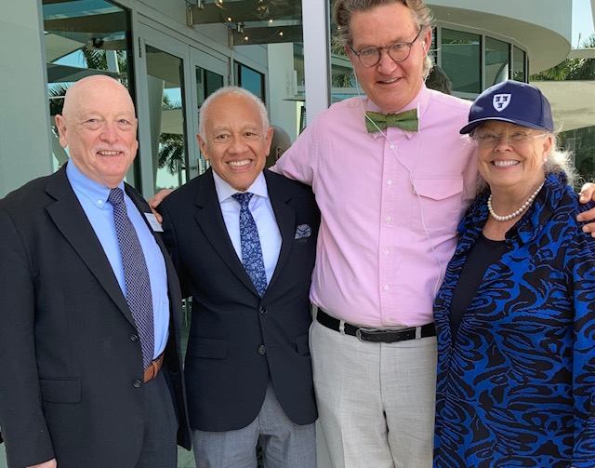
Michael Morand wearing his signature bow tie, in the company of Bob Bonds ’71 YAA Regional Representative, Club Vice President and Secretary Dr. Bruce Ballard, and Club President Elizabeth Spahn.

“Michael Morand Speaks on the James Weldon Johnson Collection:

Beinecke Library and Yale’s Mission”
Sarasota Yacht Club, January 11, 2022
By Craig Wright

On January 11, at the Sarasota Yacht Club, the Yale Club of the Suncoast welcomed the third of its speakers of the 2021-2022 season, Michael Morand, Yale College ‘87, Divinity ’93, and currently Public Relations and Communications Director at Yale’s Beinecke Library. After an eloquent introduction by the Club’s indefatigable Dr. Bruce Ballard, Mr. Morand began by posing a series of questions to the audience, among them: who wrote and published the first account of an escaped slave in America; have you heard of the 1917 New York City civil rights march or the 1921 Tulsa Race Riots; who sued the United Nations in 1947 and why; and who were the principal builders of Yale’s own Connecticut Hall? Affirmative responses were few and far between. This arresting opening gambit having piqued the audience’s curiosity, on came the gist of Mr. Morand’s talk: “Seeking History Worthy of Grown Folks.”
Important event by important event, Mr. Morand introduced--not reintroduced for most of us--several major milestones in American racial history, milestones we may have blindly passed by due to, as the speaker pointed out, the way history has been selectively taught.
But what once was lost (ignored or unknown) is now, at least in part, gradually being found, owing to the wealth of papers of influential African American writers preserved at Beinecke. To be specific: the James Weldon Johnson Memorial Collection of African American Arts and Letters, deposited in 1941, proves to be, as Mr. Morand continued to emphasize, a treasure trove of primary source information: writings, letters, photographs, and documents of various sorts.
From 1917 onward James Weldon Johnson (1871–1938) was a catalyst for many of the initiatives of the newly formed NAACP, working in a circle that included W. E. B. Dubois, and eventually Langston Hughes, and James Baldwin. Thus, documents pertaining to these three luminaries as well, are preserved as part of, or collateral to, the Johnson Collection. In such documents lie the answers to the questions posed by Mr. Morand at the opening of his presentation.
But the take-aways in Mr. Morand’s thought-provoking talk were not only the answers to the questions that he initially asked, but also the questions he insinuated along the way. As historians of culture, why do we remember some things and not others? Are we as true to the Constitution and our laws in our actions as we are to what is actually written? Does not memory loss go hand in hand with the loss of democracy? The implicit point: Institutions such as Yale’s Beinecke Library work against selective amnesia; preserving documents can preserve democracy.
It is often said that Yale University has three missions: the creation of knowledge, the dissemination of knowledge, and the preservation of knowledge. Michael Morand’s talk reminded us of how important collections like those at Beinecke Library are to all three agenda.
*****
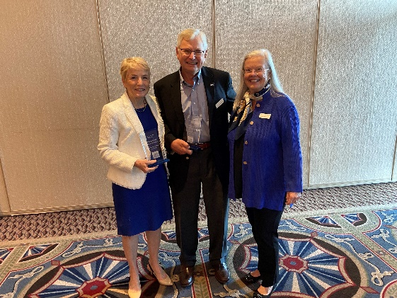
Recent Yale Club of the Suncoast Presidents Elaine Gustafson and Rick Lannamann received the YCS Award for Distinguished Service from current President Elizabeth Spahn at the Sarasota Yacht Club.

“Welcome Back Cocktail Party”
Sarasota Yacht Club, January 16, 2022
By Trudy Mulvey

The earlier threat of tornados on Sunday, January 16, 2022, did nothing to impede the intrepid Yalies from gathering to celebrate a long-awaited return to "normalcy" in this Covid 19 era. The forty-one Attendees seemed very pleased to meet at the Sarasota Yacht Club and visit with new and familiar faces once again. Fortunately, the rain stopped, the weather cleared, resulting in a spectacular view of Sarasota Bay. Everyone enjoyed the pleasing guitar music performed by the talented Peter Simms, as well as the large variety of tasty foods provided by the efficient and pleasant employees of the Yacht Club.
Oliver Janney, Past President, along with Nick Baskey, greeted all the arrivals and the socializing began. Trying to meet everyone is always a challenge, but the following are a few of the people I had the pleasure of greeting. Dr. Bruce Ballard and his wife, Eleanor, were among the early arrivals, as were the Gleasons, Dave and Joan. Joan is a representative guest from Mount Holyoke who attends our luncheons. Other Yale stalwarts included Joycelyn Baskey, Dr. John and Gretchen Bullock, and Steven and Susan Delman were also to be seen. I look forward to meeting more of our members and apologize for any I may have neglected to mention.
Also in attendance were current President Elizabeth Spahn, and several past presidents, among them Dyer Wadsworth and his wife Beverly, the aforementioned Oliver Janney, Kenneth Schneider (Mayor of Longboat Key) and his wife Cynthia Craig, Elaine Gustafson and her husband Bill Chorske, and Rick Lannamann. Membership director Clarissa Moore and her husband Michael Petrino, and Communications Director and Young member Delegate, Hedi Katz, completed the Board of Directors and Officers who also participated in the event.
The Board of Directors have approved a group of Spring Season Events listed through May 10, 2022. Please check the web site for the schedule of events to determine what may be of interest to you so you can RSVP. The officers want everyone to enjoy the activities of the Yale Club of the Suncoast. I'm looking forward to meeting more of you.

*****

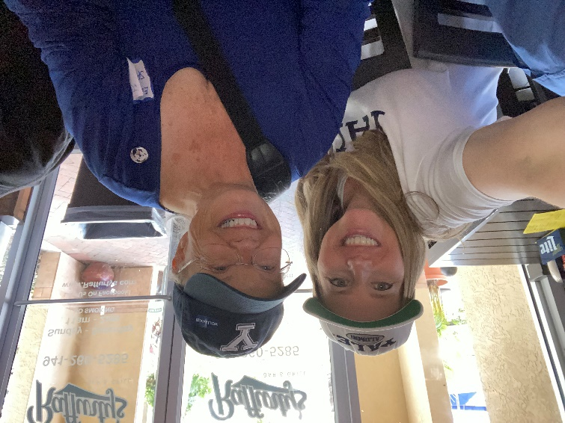

Board Member Hedi Katz, SOM ’93 at the 2021 Yale-Harvard Party

“Move over Stanford: Yale Embraces Entrepreneurship,
Local Team Wins Recognition”
By Craig Wright and staff

Stanford has long been an important part of the Silicon Valley startup ecosystem, with many famous companies (e.g., Google) emerging from university labs, incubators, or entrepreneurship programs. Now Yale is doing the same, and a company in Sarasota, headed by our own Hedi Katz, SOM ’93, has been selected as a finalist in an Accelerate Yale pitch competition.
Accelerate Yale, a Yale Alumni Association Shared Interest Group, is composed of “alumni and friends of Yale who are engaged in innovation, tech, and entrepreneurship.” In October, they hosted a “pitch off” for female founders. Hedi was selected as a finalist to present her company, Advasys, to a panel of five guest judges – Yalies who are managing directors of private equity and venture funds.
Accelerate Yale is part of other Yale entrepreneurship-support efforts. The Tsai Center For Innovative Thinking (CITY) supports student projects directly with training, mentors and some seed funding. Startup Yale is a pitch competition each Spring, with several significant prizes helping student-led groups fund further development. The Yale Entrepreneurship Society (YES) supports student-led projects with internships and incubator programs to connect students with advisors and investors. See all twelve Yale-based innovation and entrepreneurship programs listed in Entrepreneurship and Innovation Across Yale. See also the YES newsletter for the latest news.
Hedi was happy that Yale didn’t overlook alums who were launching great startups. “The quality of the other presenters and the judges was impressive. We were thrilled to be selected as a finalist.” It turns out that the Yale community wasn’t done. Hedi continued, “Several people we met have been very helpful, connecting us with human and financial resources that may play a role in our future.”
Hedi’s company, Advasys, is an online system that vastly improves the care given to people with Intellectual and Developmental Disabilities (IDD) like autism and Downs’ syndrome by alerting caregivers, family members, and doctors to often-missed issues and problems. Many individuals with IDD have trouble communicating, and caregivers may not recognize signs of impending problems. Problems that are easy to treat early, can become expensive, life-threatening crises later on.
Advasys’ clinical proof of concept trial was overwhelmingly successful. It indicated that once the system is deployed, care will radically improve and medical costs and liability for untreated conditions will fall significantly.
“This is a win-win-win situation, and I’m flattered, but not surprised, that Yale agrees,” said Hedi. “The system is composed of patent-pending intellectual property perfected over several years by my partner, Dr. Susan Abend, a nationally recognized IDD expert. It will really improve the lives of these unique individuals. Patients like my sister who has IDD and is my inspiration, win. It materially cuts costs, so medical payors are delighted. They win, which is why we have a waitlist of interested parties.And my SOM training and 16 years on Wall Street give me insight into how capital-efficient this company is so investors win too.”
Hedi tells us that they are launching a seed fundraising campaign in 2022 in order to initiate commercial availability, and she’d love to talk with any YCS members who would like to help with advice, leads, talent acquisition or fundraising – or who’d simply like to find out more about Advasys and how it supports the IDD community. Hedi Katz, Co-Founder, Advasys, hkatz@advasyscare.com, 415-606-0890.
FINIS

