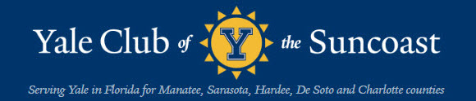

Spring 2022

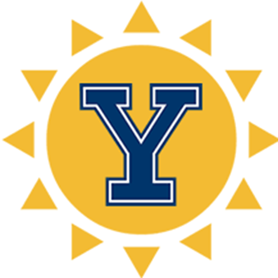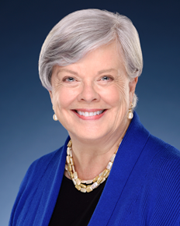
Elizabeth Spahn, President

Notice of 2022 Annual Meeting as Required per Florida Law
Presented by President Elizabeth Spahn

The Yale Club of the Suncoast Annual Meeting took place at the April 12, 2022 luncheon at the Sarasota Yacht Club. Brian Kelly presented the unanimous report of the Nominating Committee, which consisted of Frank Sampanaro, Chair, Bruce Ballard, Brian Kelly, and Dyer Wadsworth. The Nominating Committee recommended, and the membership unanimously approved, the re-election of Dyer Wadsworth, '59, Rick Lannamann, ' 69, and Ken Schneier, '74 to the Board of Directors for three-year terms ending in 2025. Following the Annual Meeting, the Board of Directors met and unanimously approved the motion of the Nominating Committee that the current slate of officers be re-elected for a one-year term ending in 2023. President Elizabeth Spahn, Vice President, Secretary and Luncheon Coordinator Bruce Ballard, Treasurer Nicholas Baskey, Assistant Treasurer Oliver Janney, Communications Director and Young Ivy Delegate Hedi Katz, YAA Representative Ken Schneier, Membership Director Clarissa Moore, Chair Alumni Schools Committee Patrick Whelan, Newsletter Editor Craig Wright, and Webmaster and Day of Service Coordinator Elaine Gustafson were all re-elected to one-year terms ending in April, 2023.

“Report from the Lacrosse Field”
By Alex Doyle

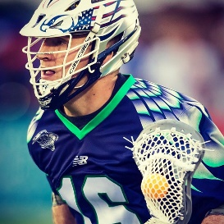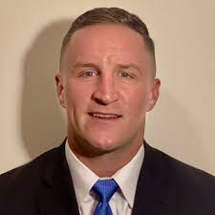
Yale Lacrosse Star Mark Glicini, ‘16, who went on to play seven years professional lacrosse, is now a sports psychology coach and member of the Yale Club of the Treasure Coast.

Hello, Yale Sun Coasters!
This is your intrepid Yale lacrosse reporter here. I want to introduce you to the current Yale 'lax' program, then hope to keep you posted on its progress, along with Yale sports in general. Hopes are high for an outstanding lacrosse season this spring, now that athletics are back in action after this sad Covid shutdown. Coach Andy Shay has assembled an outstanding new recruit class to augment an already very successful program. Prospects are strong that the Yale lacrosse team will again be contending for a national championship.
But let's first take a look at how we got here. It begins when Yale hired Andy Shay to coach varsity lacrosse in 2004. During the ensuing eighteen years Andy has built a program bringing Yale to national ranking.
It took a few years, but by 2010 Andy's teams were delivering consistent winning seasons. From 2010 through 2019, he achieved a .728 winning percentage. That's the best 10-year stretch in Eli lacrosse history. During that period, the Bulldog lacrosse team made the Ivy League Tournament every year, won the tournament five times. They also qualified for the NCAA tournament seven times, after a twenty-year drought participating in that event.
Perhaps most impressive, the Eli lacrosse team won the NCAA national championship in 2018. That followed an undefeated regular season (the first since 1956), featuring a Yale record 17 wins. Not surprisingly, Coach Shay was honored as the USILA Division I Coach-of-the-Year.
He followed up that success with another appearance in the 2019 NCAA tournament, where the Bulldogs went to the title game, lost in the finals to Virginia.
I would be remiss if I didn't mention the contribution to the team's success in these recent years made by Ben Reeves. Ben played attack for the bulldogs through his senior year in 2018. Over that period, he set numerous Yale records for goals, assists, numerous other categories. In 2018 he won the Tewarraton Award, lacrosse's version of the Heisman Trophy. Beyond that, Ben is a classic Ivy League scholar/athlete. He not only achieved national recognition on the lacrosse field, but he also graduated Cum laude. His degree? Bachelor of Arts in Molecular, Cellular, & Developmental Biology. He is currently a graduate student at the Yale School of Medicine.
So here we are now, after a two-year Covid hiatus from competition. Andy has been busy recruiting and has assembled an impressive group to carry on the Eli lacrosse success. Yours truly has some interesting personal connections to that recruiting class. I'll save those for a later edition. In the meantime, root for another successful season for Andy and his lacrosse team.

“In the Middle of Nowhere—That’s the Point:
The Yale Club Visits the Hermitage Artist Retreat”
By Craig Wright
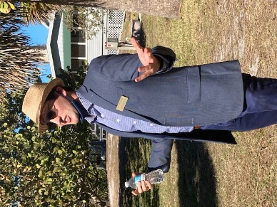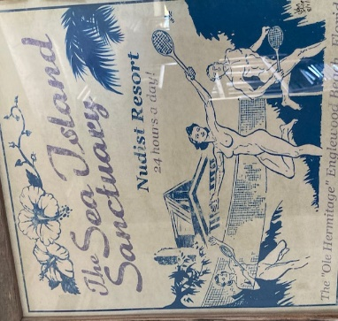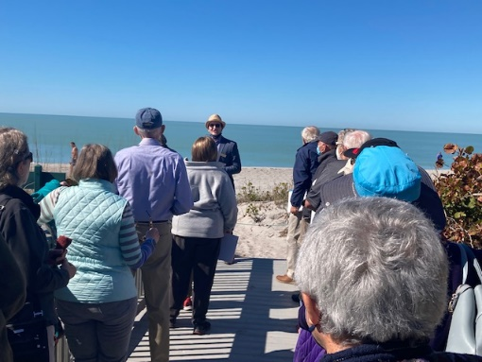
Adam Sandberg, ’05 A bit of history (and a way to check readership) Yalies looking out to sea for creative inspiration
Director of the Hermitage Foundation

On a crisp Monday morning, January 31, 2022, some approximately twenty stalwart members of the Yale Club of the Suncoast heeded the call of Program Director Rick Lannamann and headed their respective vehicles down FL 41 toward Manasota Key (where?). In the rearview mirror disappeared South Sarasota, Osprey, Nokomis, Venice, and South Venice. If there is an automobile manufacturer/distributor not represented on this leg of FL 41, it doesn’t exist. Eventually, arriving at the Hermitage Artists Retreat, more than one member of the Club was heard to exclaim: “Gosh! this is in the middle of nowhere!”
Maybe that’s the point. Derived from the old French word hermite, a “hermitage” is place where solitary hermits dwell. Historically, hermitages have been situated in isolated venues (think of the St. Francis among the mountain rocks at the Frick in New York). Saints, mystics, prophets would isolate to contemplate their particular version of god and the meaning of life. Today at the Hermitage, visitors get a taste of the old and the new. The spirit of a hermitage remains--a place where future prophets go—but today the prophets are not only foretelling, but also doing.
The Hermitage settlement began as a single beach cottage built in 1907 by Carl Johansen, an immigrant from Sweden. By the 1930s a community of half a dozen other cottages had emerged, and in 1936, the compound was converted--yes Yalies--into a nudist colony—what would St. Francis have thought!!! But ultimately the flesh was vanquished by the spirit: a nudist colony next became an artist colony. In 1999 the community was repurposed and renamed the Hermitage Artist Retreat, which incorporated as a non-profit institution in 2002 and designated a state historical site. Over time, the ramshackle cottages were renovated and sometimes repositioned back from the encroaching sea (see photos). Currently, there are seven full-time employees, led by a director, Yalie Adam Sandberg, ’05, who served as our enthusiastic, entertaining host.
Wandering the Hermitage preserve today, the visitor sees a collection of five well-appointed residential cottages that provide as a temporary home to painters, poets, novelists, composers, sculptors, and the like. The fellowship covers the cost of transportation, residence, board, and incidentals. Some Hermitage fellows have been Pulitzer Prize winners, others MacArthur Fellows. As with those prestigious awards, as well as with the Nobel Prize, one does not apply for a Hermitage fellowship, one is chosen by an independent jury of peers. Each year twenty fellowships are awarded for a four-week residency, which can be spaced out over two years. Children, partners, pets, and other potential distractions are precluded. But unlike the original medieval hermitage, interdisciplinary discussions among residents are encouraged. In fact, they are required. At least once during an artist’s stay, the fellow is required go among the masses to publicly profess his/her art at schools and arts groups, or before the general populace.
During our pleasant outdoor box lunch, Yale alumni were privileged to hear from two current resident artists. Poet-novelist-librettist Terese Svoboda spoke about the creative process and how each of media in which she works requires a different “marketing” strategy before it can be published. Broadway playwright and Pulitzer Prize winner Michael R. Jackson said that while at the Hermitage he was preoccupied with “getting a pitch out the door”—trying to fashion a proposal for a new work that will attract Broadway agents and producers.
A question that came up after Jackson’s presentation: What do you do here at the Hermitage that is different from the type of creative thinking that you do elsewhere? To this Jackson responded: “I’ve had artist residences in Wyoming (near Sheridan) and here on Manasota Key. The one in Wyoming allowed me to rest, but the one on the Gulf of Mexico has been a much more creative experience. I just go to the beach and sit in a chair. There is something about being near the ocean that frees up my creativity; it allows me to tap into my subconscious. I just stare at the water. I watch the patterns of the waves. I listen to their sounds and their rhythms.” Maybe the “take-away” from today’s visit was this: Find chair, go to beach, look at water, and get creative.
Leaving the Hermitage, one could not help but feel that our fearless Program Director Rick Lannamann was right. Yes, the Hermitage was far down the Tamiami trail, but the trip got us out of our comfort zone and made us think about how artists work their magic. Nice job, Rick!
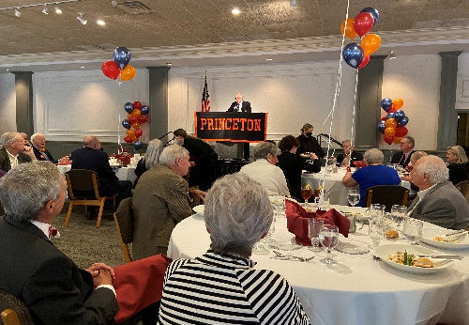
2022 Sarasota Yale-Harvard-Princeton hosted this year by the Orange and Black

“The Annual Yale-Harvard-Princeton Luncheon”
By Trudy Mulvey

Dr. Justus Doenecke was the speaker for our Yale-Harvard-Princeton Luncheon on February 11, 2022, at Michael's on East. He is an American historian, writer, and professor, and presented his very interesting views on the Cold War with Russia, which last from 1962 until 1989.
Professor Doenecke described General Secretary Leonid Brezhnev as a leader who expanded Russian military spending by 3% annually and required all men over seventeen years of age to serve in the military. During Brezhnev’s tenure, Russia increased its third-world presence. However, Russia became spread out geographically, and the Soviet border came under threat. Although the Soviets were a large oil producer at the time, Russian civilians experienced poor living conditions. The military consumed 30 to 40 percent of the Gross National Product, and during the 1970's, Russia was forced to import foreign food to feed its people. In 1964 the male lifespan was sixty-six years, but by 1984 the lifespan had fallen to sixty-four years. Brezhnev was described as a country boy whose only trusted advisor was his wife.
In 1985 Mikhail Gorbachev succeeded Brezhnev, and in 1986 Gorbachev began addressing the issue of progress at home. He first eliminated holdovers from his own generation and increased incentives for the post Stalin generation. Gorbachev removed subsidies, which increased shortages, and he decreased prices and reduced tax revenues, which weakened the economy. Gorbachev liked the movies which helped him establish a good rapport with President Ronald Regan.
Between 1988-1991 relations between Russian and the U.S. began to improve. In 1987 Russian groups were allowed to assemble. In 1989 the first free elections in Russia were held. All governmental perks were removed. Communism began to change, and the Soviets lost power, culminating with the fall of the Berlin Wall in 1989. Henceforth, the Soviets mainly were on their own. In 1991 most of the Baltic states broke away from Soviet control. In 1991, in a coup lasting three days, Gorbachev was placed under house arrest, and Boris Yeltsin assumed the governance of the country. On November 25,1991 Gorbachev resigned from the Presidency.
Although Dr. Doenecke’s lecture was essentially a recitation of the facts, judging from comment overheard afterwards, the presentation was a thoroughly enjoyable experience for the participants.

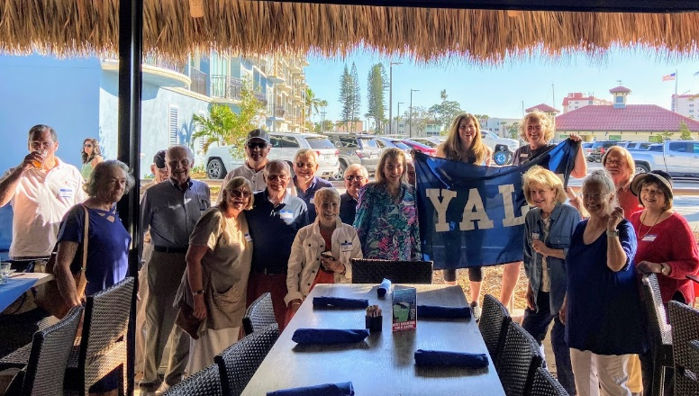

Good, clean February fun in Venice with the Feb Club, a continuation of
a grand, old Yale tradition.

“ELIne Feb Club 2022”
by Nurit Sonnenschein

On Sunday, February 20, 2022, the Yale Club of the Suncoast rekindled our annual Feb Club celebration after a 2021 COVID-induced hiatus. More than twenty-five Yale Club members and half a dozen All-Ivy members enjoyed terrific appetizers and scintillating company on a gorgeous sunny afternoon at the Dockside Waterfront Grill in Venice. As always, Feb Club was purely social – no agenda, no speakers – just a party.
Commemorating the college tradition established in the late 1970s of battling New Haven's winter doldrums by offering a party somewhere on campus every night during the month of February, Feb Club for Old People was the brainchild of a few ’87 derelicts enjoying a liquid lunch at the Yale Club of NYC in 2008, musing about the February glory days in New Haven.
Believing the Feb Club renaissance idea meritorious, the Yale Club of NY planners started making some phone calls. They hoped within a few years’ time to grow to twenty-eight parties in twenty-eight days in twenty-eight cities. This was rather a low bar -- first, because it was a leap year; but much more so, because some of these individuals had been known to attend Feb club parties every night while in New Haven! Having just one party per city ensured no excess February frivolity for any one celebrant, and a high likelihood of maintaining current employment for all. It would have been interesting to know to what extent Toby Keith’s immortal song “I ain't as good as I once was, but I'm as good once as I ever was” impacted the planning and discussions; but alas, such knowledge has been lost to time.
We do know that a flurry of excited emails and phone calls confirmed a universal desire to revive Feb Club, and within a few weeks, the organizers had thirty-five enthusiastic hosts across the country planning parties. The indecorous “for old people” was ditched, and the much better sounding Feb Club Emeritus was launched.
Feb Club has had astonishing staying power and appeal. By 2009, only its second year, Feb Club parties were hosted in sixty-two cities and attended by over 5K alumni representing classes from 1941 to 2008. Since then, the tradition has continued to expand, with over 1,000 Feb Club events hosted in locations around the globe. The Yale Club of the Suncoast joined the tradition in 2019.

“Professor Amar Shares His Newest Book with the Club”
By Oliver Janney
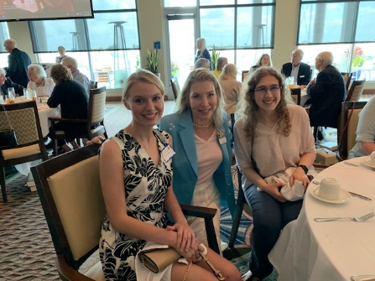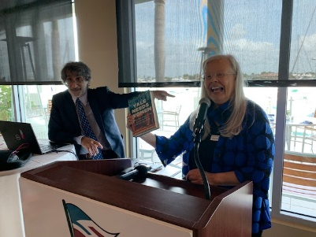
Emma Smith, Clarissa Moore and Kassandra President Elizabeth Spahn introducing
Haakman about to hear Akil Amar Professor Akil Amar

At our luncheon on March 23rd, Sterling Professor of Law and Political Science Akhil Reed Amar shared with us insights from his newest book The Words that Made Us: America’s Constitutional Conversation, 1760-1840. Professor Amar is a Summa cum laude graduate of Yale college and a graduate of Yale Law School. He describes himself as a lifelong Yalie: He came as a freshman in 1976 and has never left Yale. He started teaching at 26 and is now a Yale parent with two of his three children currently attending. Professor Amar is the only currently active professor to have won the University’s unofficial triple crown – the Sterling Chair for scholarship, the DeVane Medal for teaching, and the Lamar Award for alumni service. Professor Amar asked that anyone who obtained his latest book read at least the first chapter.
He is certain that any reader will then plunge further into the huge volume. He declared, “I’m like a virus. I want to get inside your head.” Professor Amar noted that his new book is the first of three on the words that have made America what it is today. The second volume will be The Words that Made Us Equal, 1840-1920, and the third will be The Words that Made Us Modern, 1920-2000.
Professor Amar devoted the rest of his talk to reading portions of the chapter on Andrew Jackson in his new book. He focused on three presidents who strengthened the position of the Constitution and addressed what he deemed a fatal flaw in the Constitution.
Professor Amar described Jackson as a synthesis of Washington and Jefferson and the three as America’s greatest presidents in the first 60 years under the Constitution. Professor Amar specified the criteria for great presidents. They needed a second term to show that they could win and keep the office. They were tried in war and national security. Some exceptional character or significant achievement was also necessary.
Professor Amar showed that the three greatest presidents did great things before office and great things in office. Washington became, in Professor Amar’s view, the world’s greatest person. The Constitution was Washington’s; it reflected his desires. The people voted for it twice, events that had never happened before in history. Washington was unanimously elected (in terms of electoral votes). Jefferson was the creator of the first national political party and supported its rise with an affiliated newspaper. Jackson bested the British on the battlefield in his victory at New Orleans. Jackson had also expanded the nation by wresting land from the Creek Indians, seizing control of Florida and overseeing the acquisition of Chickasaw land in Kentucky and Tennessee for a modest cost. Jackson remade his party, the Democrats, with the aid of newspapers.
Once in office, each of the three greatest presidents continued to achieve. Washington established the union. Jefferson doubled its expanse. Jackson kept the country together, despite the efforts of nullifying extremists, including his Vice President. All three contributed to the acceptance of the Constitution. Washington showed that the system could work. Jefferson showed that the system could work under someone other than Washington. Jackson showed that the next generation could do the job.
However, the Constitution had a fatal flaw. Slavery was not only tolerated but privileged. Professor Amar asserted that a basic weakness in the Constitution was that there was no provision for phasing out the Three-Fifths Clause. He pointed out that until Lincoln, all presidents were slaveholders or northern appeasers. All three of America’s first greatest Presidents were slaveholders. Jackson represented slavery’s growth to the west and gave the Supreme Court Roger Taney.
In responding to a question about free speech at Yale, Professor Amar stressed the need to allow speakers to speak to audiences. He insisted, “We are a university. It is about probing and discussion of issues. We are a law school. You can’t shut off discussion in a courtroom or deposition. If they do it in court or a deposition, the judge will chew them out.”
In response to another question, Professor Amar explained that a thesis of his book is that we Americans govern ourselves by speech, in writing and through pamphlets. He asserted that the Constitution was adopted for geostrategic reasons. Without a union, other nations might try to gobble us up. He noted that every early president before Lincoln, except Polk, had been a general or a leading diplomat.
Alumnae of Mount Holyoke and Smith joined us for the luncheon, as did some members of the Ivy League Club. The discussion was an intellectual tour de force that made us all proud to be alums of Yale. I personally hope that we again take up Professor Amar on his offer to return sooner than later.

“Yalies at the All Faiths Food Bank - Day of Service”
by Elaine Gustafson

On April 4, 2022 group of stalwart members from our Yale Club of the Suncoast joined with a hearty group of volunteers in an assembly line at the All Faiths Food Bank to make bags containing a variety of foods for distribution to children to bring home from school in their backpacks. There was much discussion and camaraderie as the group gathered the items and filled the bags. The time flew by and all were in agreement that they enjoyed the experience and would happily come again. All Faiths Food Bank volunteer coordinator Victoria Hasselbring noted that she greatly appreciates this volunteer effort and would welcome us back more often if volunteers are available.
(SHOULD YOU WISH TO PARTICIPATE IN A YALE CLUB DAY OF SERVICE, please consult the link below. Please note that some of these are virtual, and you can participate from anywhere.)
Events Calendar | Yale Alumni Association

“The Annual Yale Club of the Suncoast Sunset Cruise”
By Brian Kelly
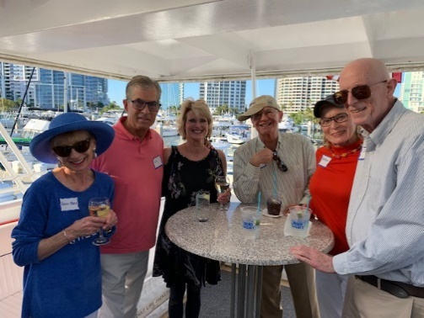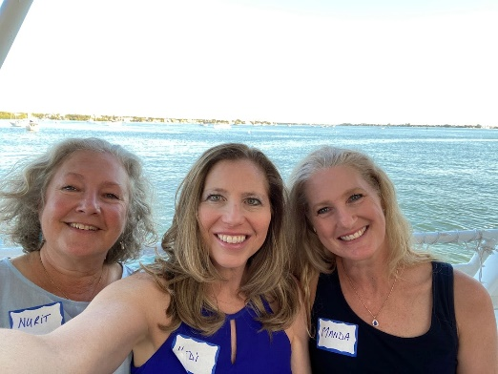

Yalies, including board members Beverly & Yalies Nurit Sonnenshein, Hedi Katz, and
Dyer Wadsworth (right) about to cast off Harvard Club of Sarasota President Manda Jordan at sea
At 18:15 hours, on a gorgeous Sunday evening, April 10, 2022, some forty-eight Yale Club of the Suncoast sailors boarded the MJ II for what was later called a marvelous and memorable dinner cruise. The Yalies migrated to the reserved Captain’s Upper Deck, stormed the bar, and rallied in the picture perfect weather of the cabin and ship’s fantail cocktail area. The attached photos attest to the spirited camaraderie enjoyed by all - including President Elizabeth Spahn’s guest, Manda Jordan, President of the Harvard Club of Sarasota!
With a mighty blast of its sea horn, the MJ II cast of it lines and began its journey out Big Pass. This afforded the Blues a very close view of the impressive homes of Bird Key and the many small boats fishing in the Pass. Just before reaching the Gulf, Captain Jack Hill turned and followed the north portion end of Siesta Key. He then paused the boat for a few minutes to provide a fabulous sunset view afforded by a cloudless sky. While no one spotted a green burst on the horizon, in true Eli tradition, Happy Hour continued unabated!
As the ninety-six-foot boat approached the Ringling Bridge, the Quartermaster advised dining was now available. The buffet offered an abundance of salads, vegetables, delicious grilled salmon, and roast beef at a carving station with a most “magnanimous” chef. The coup de grace was a desert table featuring key lime pie, chocolate cake and strawberry cake.
As dinnerware was cleared and the MJ II returned to her pier, Nick Baskey valiantly provided the pitch to a group of accomplished Yale singers featuring: Jamie McLane, Ken Schneier, Rick Lannamann, Elizabeth Spahn and yours truly. They fired up fellow Elis with renditions of “The Whiffenpoof Song” and “Bright College Years.” Elaine Gustafson then presented Captain Brian with a commemorative Yale cap which ignited a spirited version of “Bulldog, Bulldog, Eli Yale.”
At this point, our Harvard guest declared she was most impressed with the spirit of the Yale group - so too was this writer and all participants. Thank you!
Yours, Captain Brian
“Trash Talking Environmentalist: Prof. Thomas Culhane”
By Craig Wright
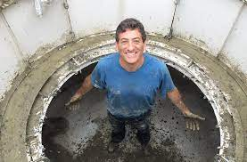
Prof. Thomas Culhane, coming out of some recycled and highly valuable, muck

On April 12, club member Peter French introduced Prof. Thomas Culhane as the Yale Club of the Suncoast’s final speaker for the 2021-2022 season. Professor Culhane is currently Director of Programs in Climate Mitigation and Adaptation at the University of South Florida. The official, albeit whimsical, title of the lecture---“The Solution to Pollution: The Daily Grind”---suggested that the audience was expecting to be surprised.
No one was disappointed. Yes, the subject matter was “upcycling wasted food and plastic into fuel, fertilizer, and building materials.” But how to you transform an important seemingly dreary topic such as food waste into something fun and memorable? You create a song and dance routine! Suddenly, we fifty or so Yalies were bumping and grinding to the words “Just shred it, grind it, and granulate (Clap) Granulator (Clap)” driven by the infectious singing and ukulele playing of Prof. Culhane. Who knew our environmentalist is a talented public performer capable of lifting the mundane into something entertaining and, indeed, educationally uplifting? In quick succession, we learned why food waste disposers are the key to our sustainable development. How waste can be turned into microbial fertilizer (indeed, it is now being used as such on the 45 holes of golf at the Longboat Key Club). We learned how garbage can be turned into methane gas and used as a less harmful fossil-fuel substitute. And we learned how the plastics we stuff in our rubbish bin can, if sorted property, be transformed into building boards, linoleum floors, and new plastic chairs. As he spoke, Prof. Culhane’s barely two-year old son, Naigh, free-ranged the room, subtly reminding all of us soon-to-become-fertilizer why such a presentation matters. Good lectures can be informative, potentially transformative, or fun. Great lectures are all three. Thanks, Prof. Culhane.

FINIS: LUX ET VERITAS

